**LOG ANALYSIS USING SPARK PROJECT – 1**

**PROJECT OVERVIEW:**

This project aims to provide a data analysis solution for log data using azure databricks. Here the log data is sourced from a python code. We utilize Azure Data Factory to ingest the log data into azure storage, and leverage azure databricks for log analysis using Apache spark for insights such as error rates, trends and anomalies.

**HOW IT WORKS:**

**Source Data:**

The project is based on log data. So, I have generated a log data using a python code. The generated file is “log_data.csv”.

**File Name Type**

Log_data CSV

Below the code for log data generation:

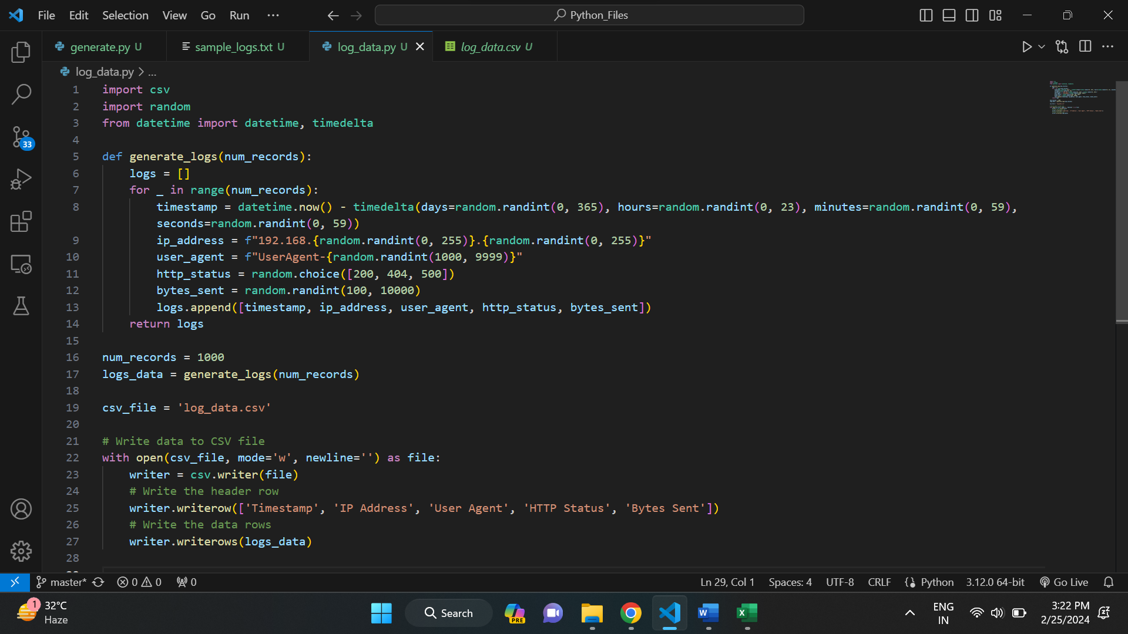

Below is the generated log_data.csv file. In this we have columns like:

1. **Timestamp:** It contains the details of login time.
2. **Ip Address:** It has the Ip address of the system through which the user is logged in.
3. **User Agent:** It contains the user id.
4. **HTTP Status:** It has the http status code.
5. **Bytes sent**: It shows the number of bytes sent during logging.

This is all about log data. Below is the glimpse of it.

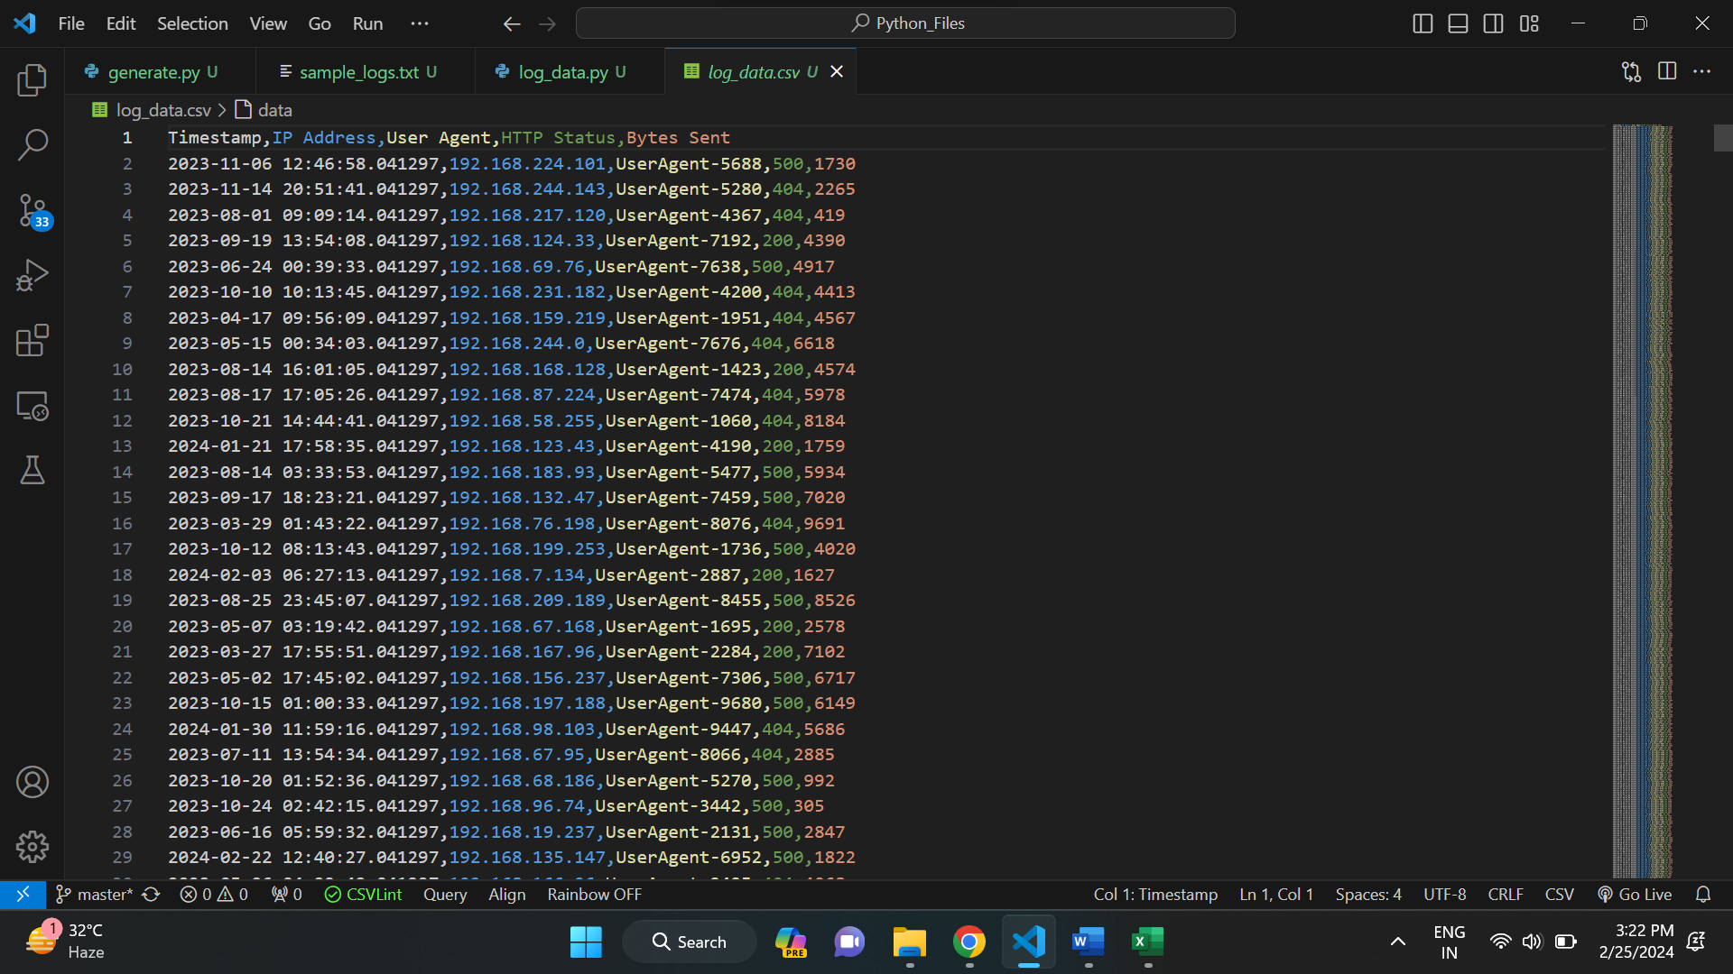

**Execution overview:**

* We use azure data factory to ingest the data into azure blob storage. And then, we link the azure storage account with azure databricks using access keys in the storage account.
* After linking the services, we mount the data into azure databricks for direct access. Now we can directly access the data from azure databricks storage.
* Now we apply data cleaning and data transformation techniques on the loaded log data. After that we visualize the data
* Finally, we find the error rate and trends the data.

**AZURE RESOURCES USED FOR THE PROJECT:**

* Azure Data Factory
* Azure Storage account
* Azure Databricks

**PROJECT REQUIREMENTS:**

The project requirements are broken down as below:

1. **Data Ingestion Requirement:**

* Generate a log data
* Ingest the log data into Azure storage account
* Use data factory for the copy activity
* Copy the data into the azure storage account by creating pipeline
* With this data ingestion gets completed

1. **Connection Requirement:**

* For this first create an azure databricks account
* Find the storage account name and key from access keys
* Create a cluster and a new notebook in the databricks
* Initialize variables with name and key of the storage account
* Use conf.set to make a connection between the databricks and storage account
* With this both services are connected

1. **Data Cleaning and Transformation Requirement:**

* In this we use pyspark methods to clean and transform the data
* Firstly, we remove the null values either my dropping the rows or by filling the missing values
* Next, we transform the data if necessary
* In the end, we visualize the data for better understanding

1. **Data Analysis Requirement:**

* The analysis part involves various tasks
* We find the error rate
* We discover the trends in the data

**TASKS PERFORMED:**

There are various tasks performed in this project:

* Build a data engineering solution for analysis of log data
* Created a sample log data using python
* Used Azure data factory for the copy activity of the data into the storage account.
* Used Azure databricks to write the code for analysis
* Established a connection between Azure storage account and Azure databricks through access keys
* Mounted the data into the azure databricks storage
* Performed the data cleaning and transformation operations
* Visualized the data
* Written pyspark code for finding error rates
* Written pyspark code to identify the trends in the data.

**OUTPUT/ RESULTS:**

Go to azure portal and select the storage accounts.

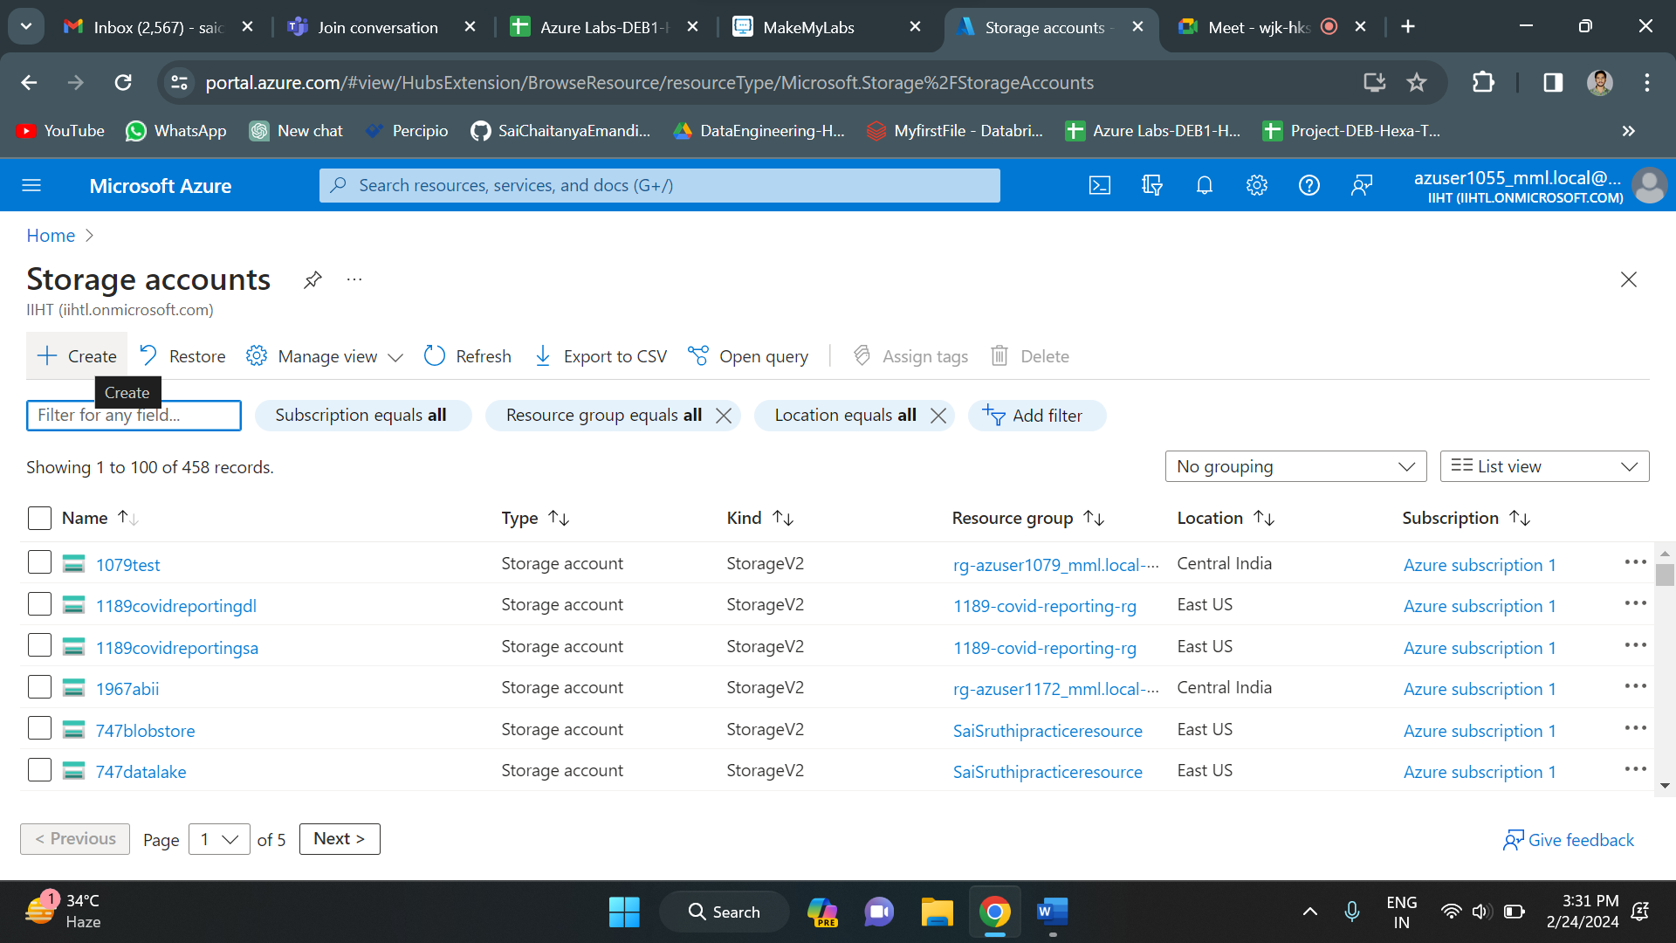

Create a new storage account. Click on create option to create a new storage account. Configure all the details and click on create below.

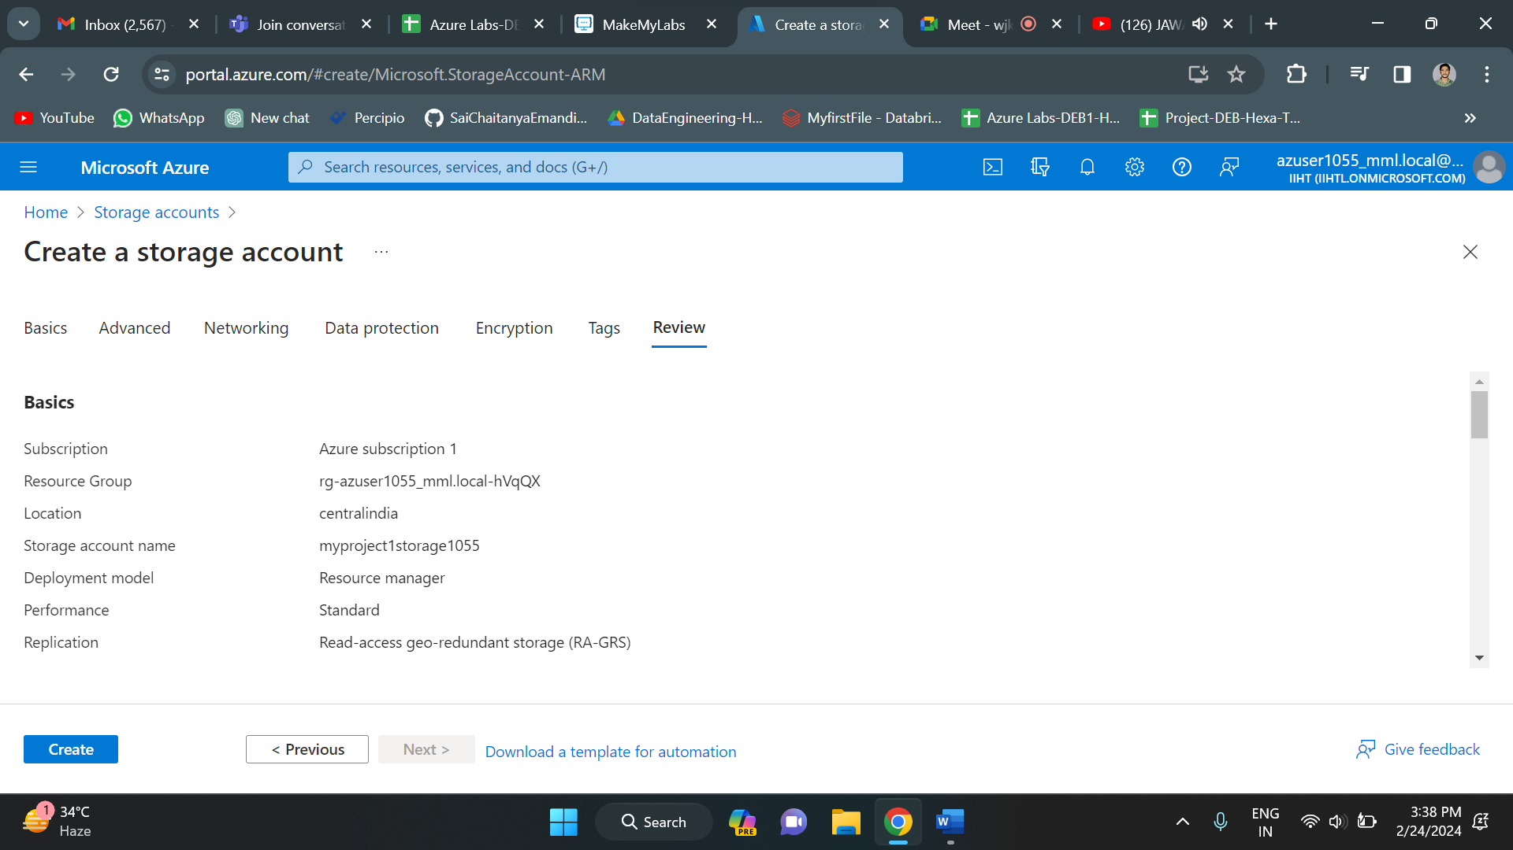

Once you click on create, the deployment of storage account will be initiated. As you can see below, the deployment is in progress. Once the deployment is completed, click on go to resource.

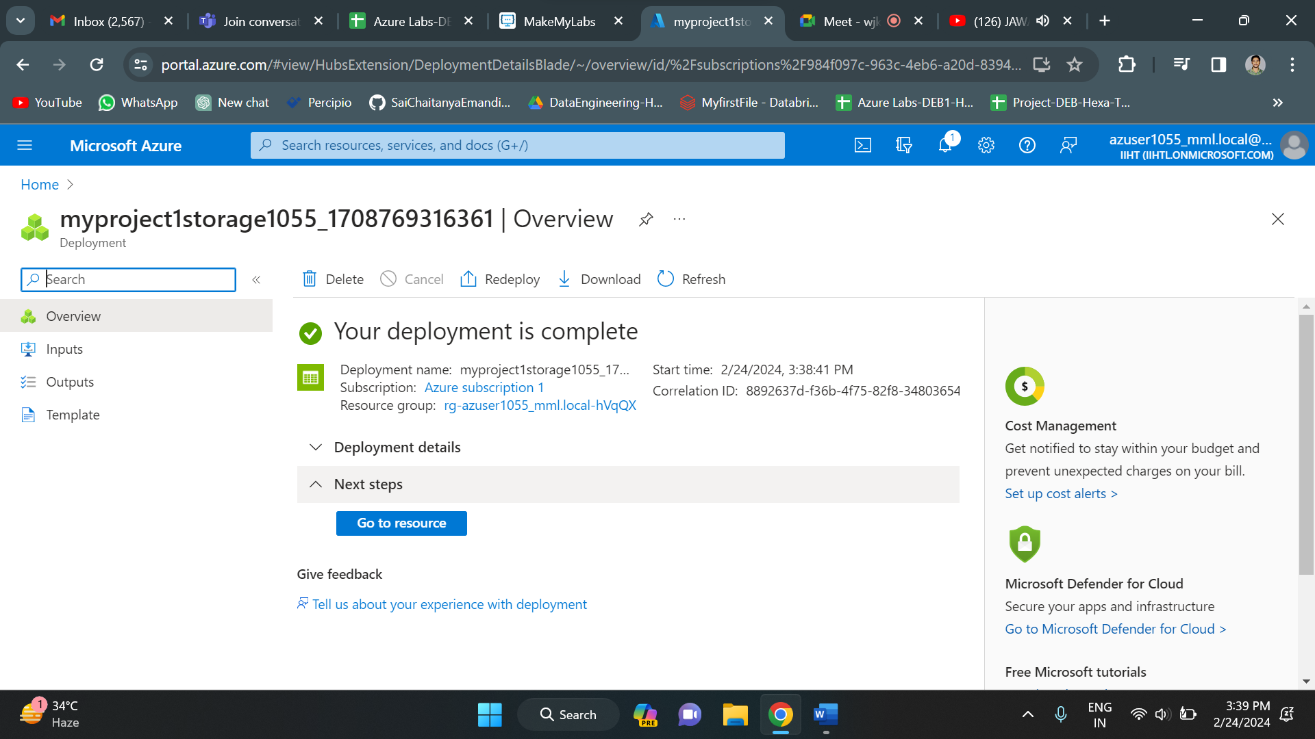

Below is the overview of the storage account. It displays all the details regarding the storage account like name, resource group, location, performance, subscription etc.

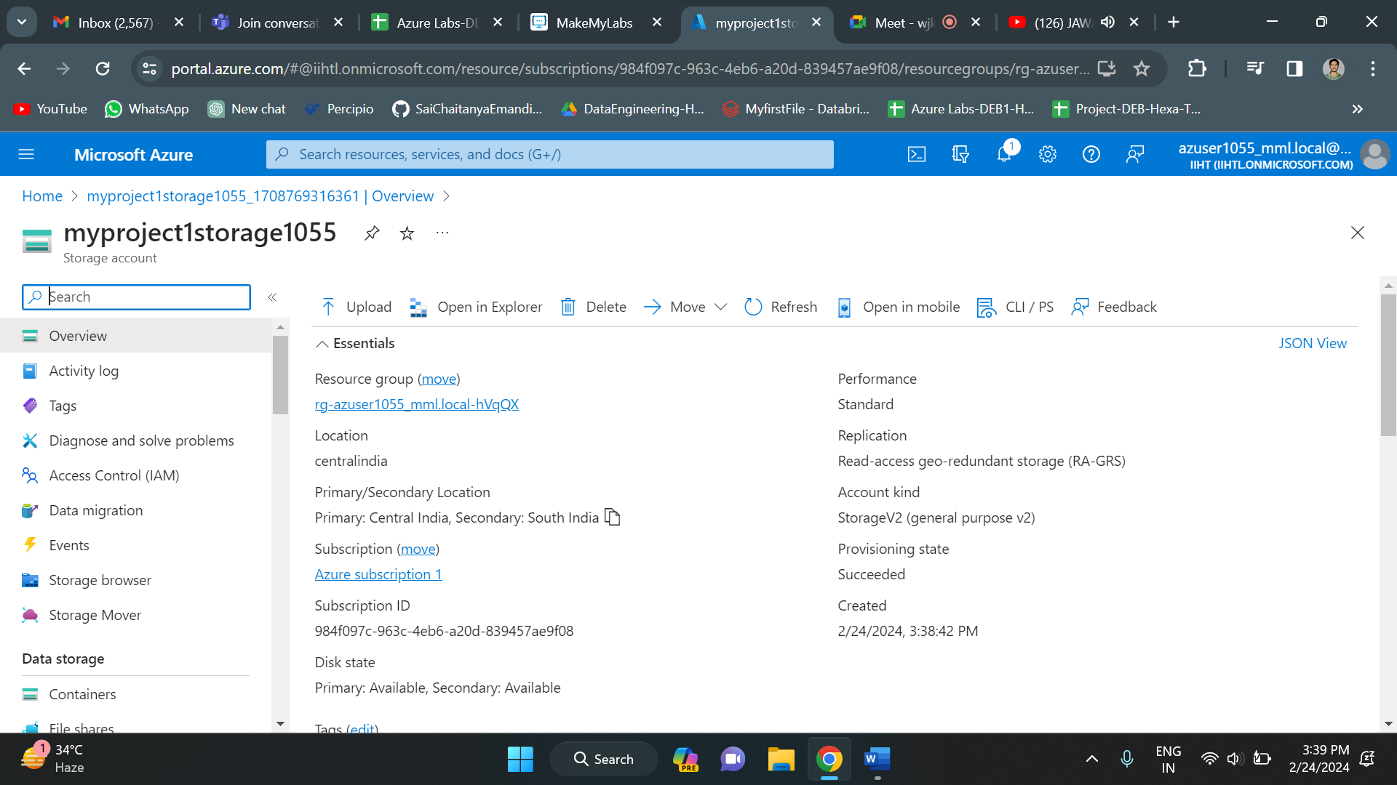

On the left menu, we have a containers option. Click on that to create a new container which holds the files that are uploaded. As you can see below, click on “+ Container” option to create a container and specify container name and click on create. Container name “mycontainer” is created.

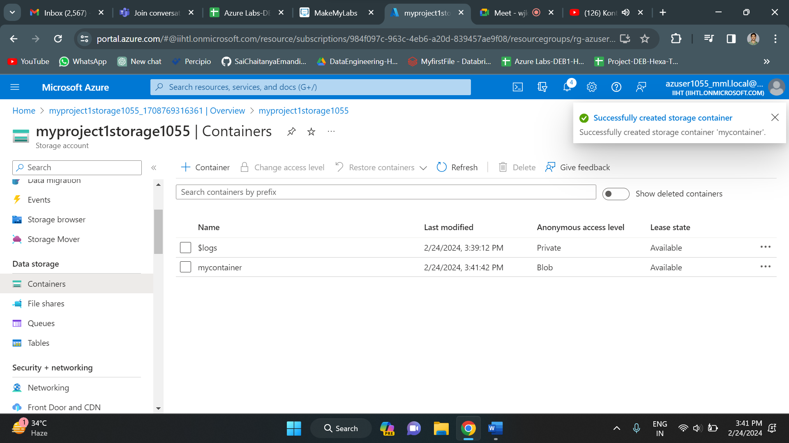

Since Storage account is created, we need to create a Data factory. Select Data Factory and create new data factory.

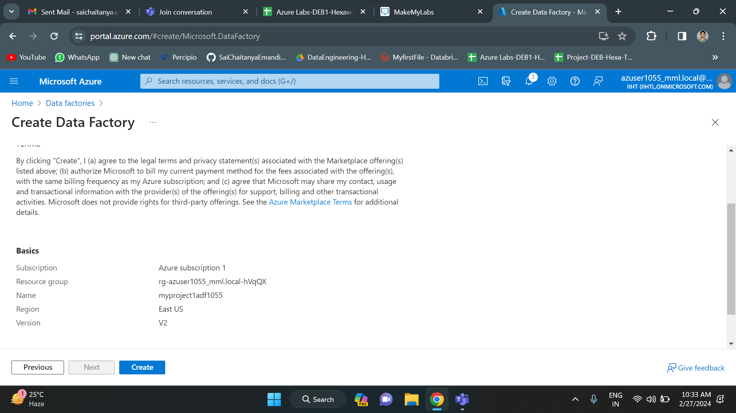

Once the Data factory gets created launch the data factory studio.

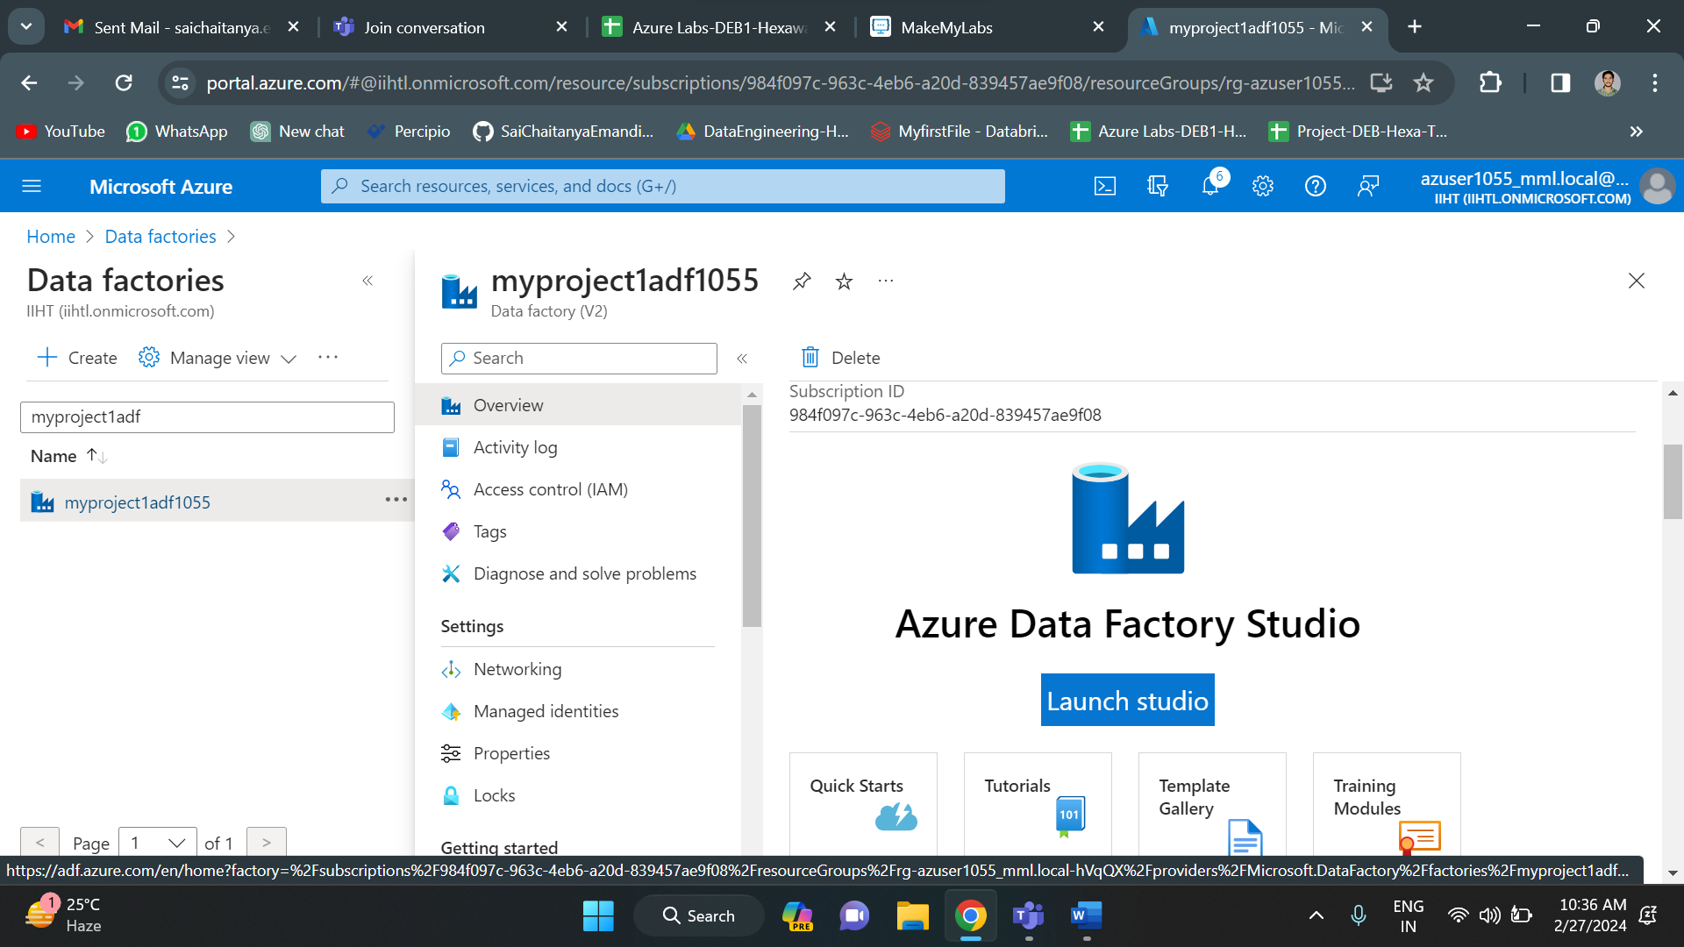

Below is the home page of data factory. Click on ingest.

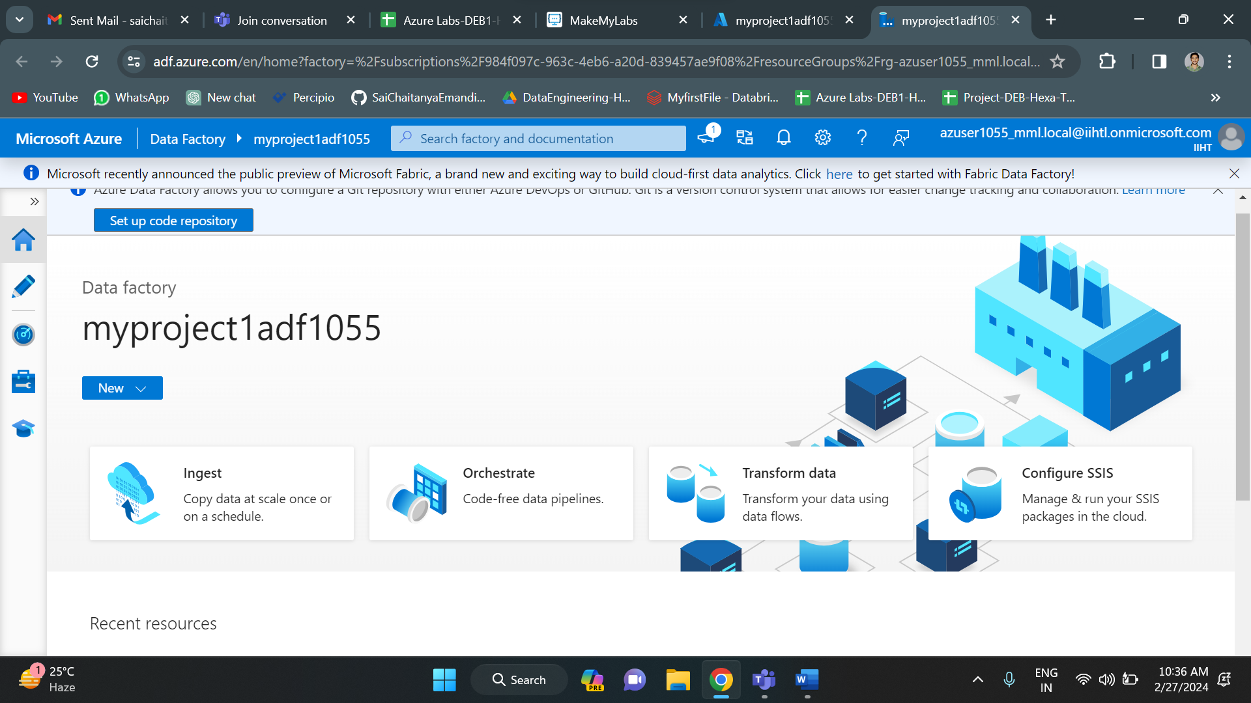

Now give all the details required for the copy activity.

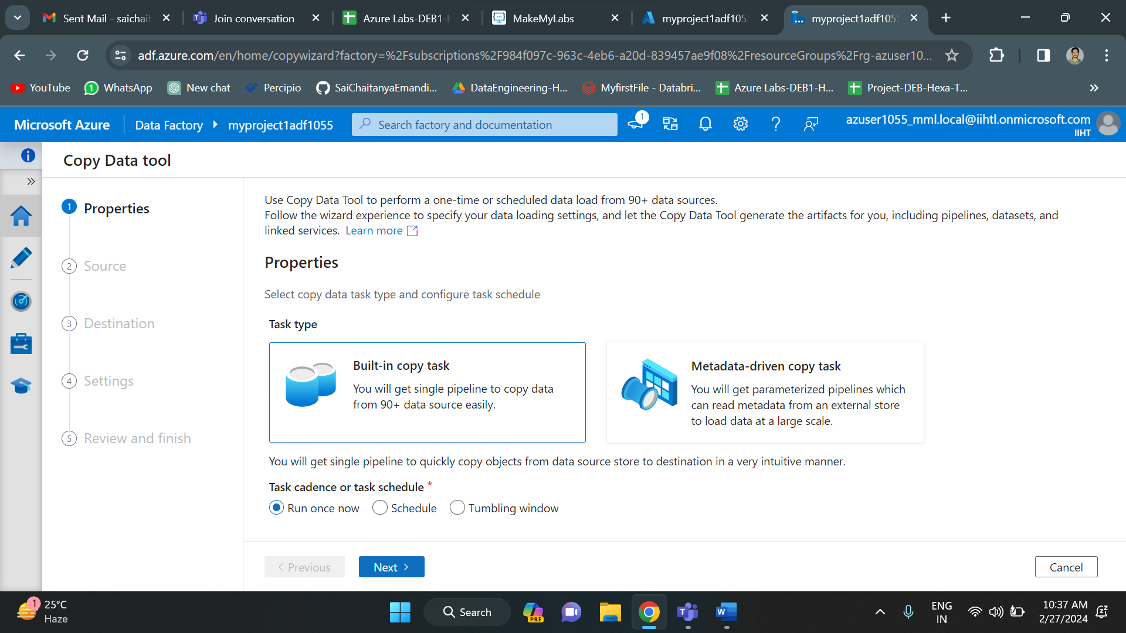

Set up the source details by selecting new connection.

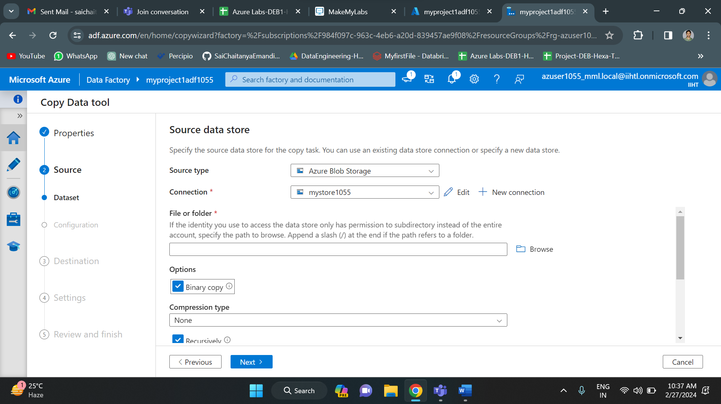

Similarly set up the destination and click on finish. After that the deployment of the pipeline starts.

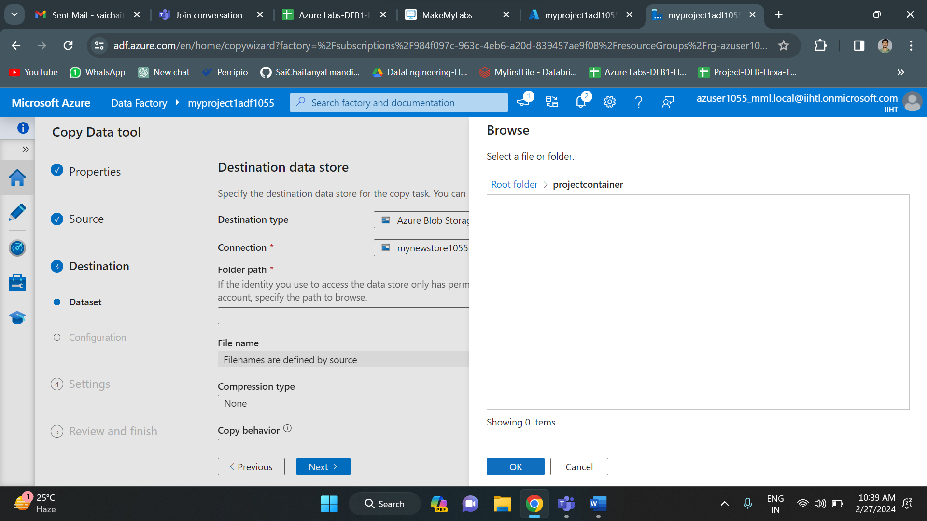

Once the deployment gets completed, Click on finish.

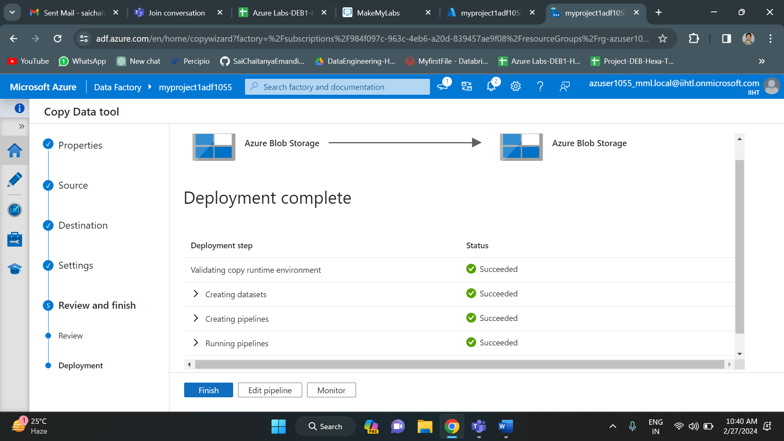

So, I have successfully created a pipeline and ingested the data into azure storage account. The pipeline has been validated and debugged successfully.

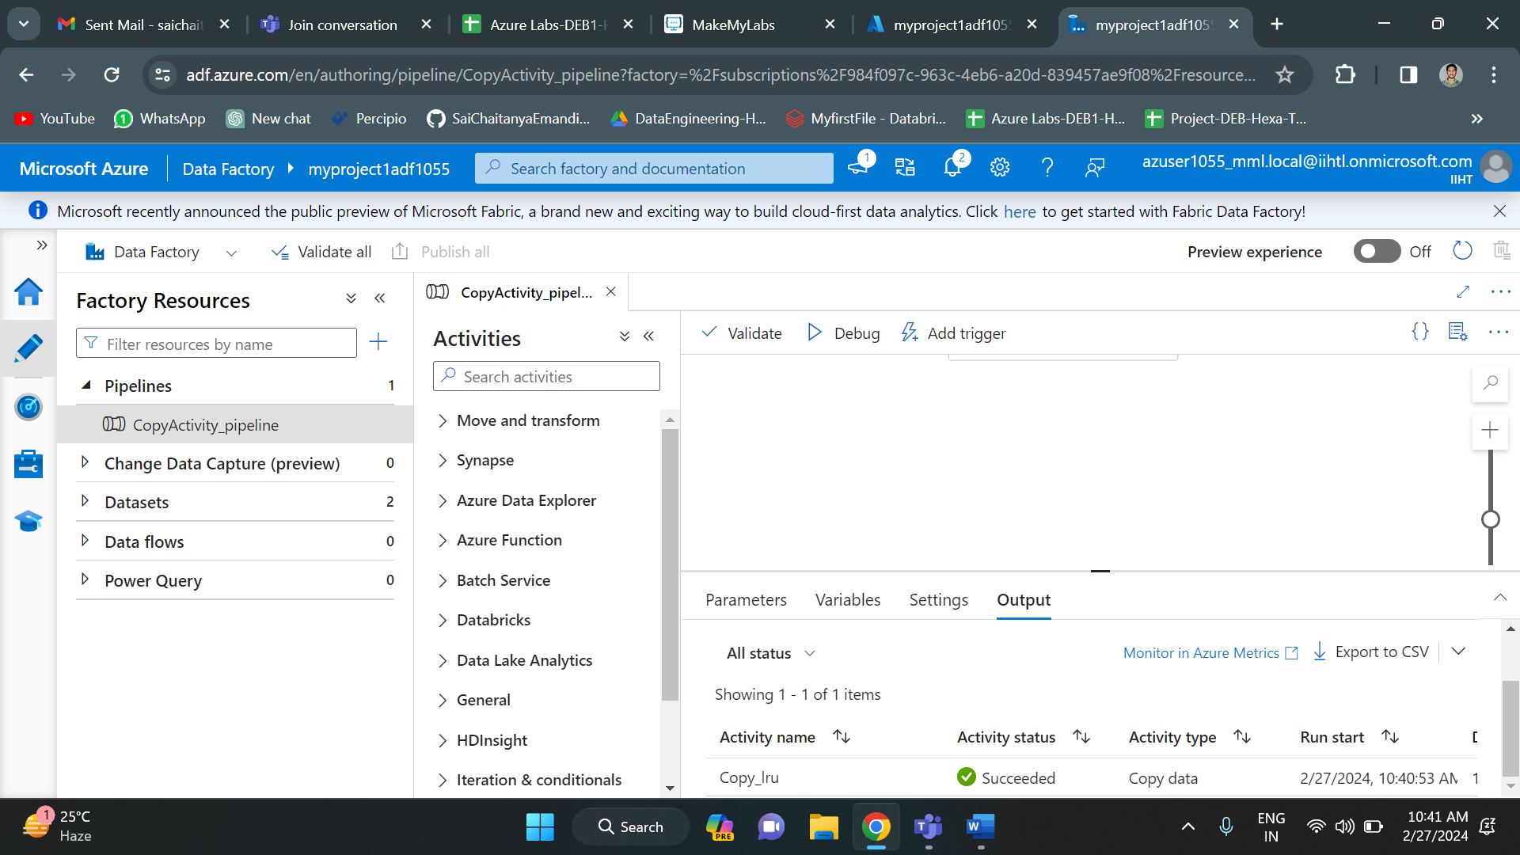

Finally, we have ingested the data into storage account using data factory. Now we have to create an azure databricks account and do analysis on this data.

To create an azure databricks account, we need to go to azure portal. In that azure portal search for azure databricks. Click on that to create an azure databricks account.

Now click on create to new azure databricks account.

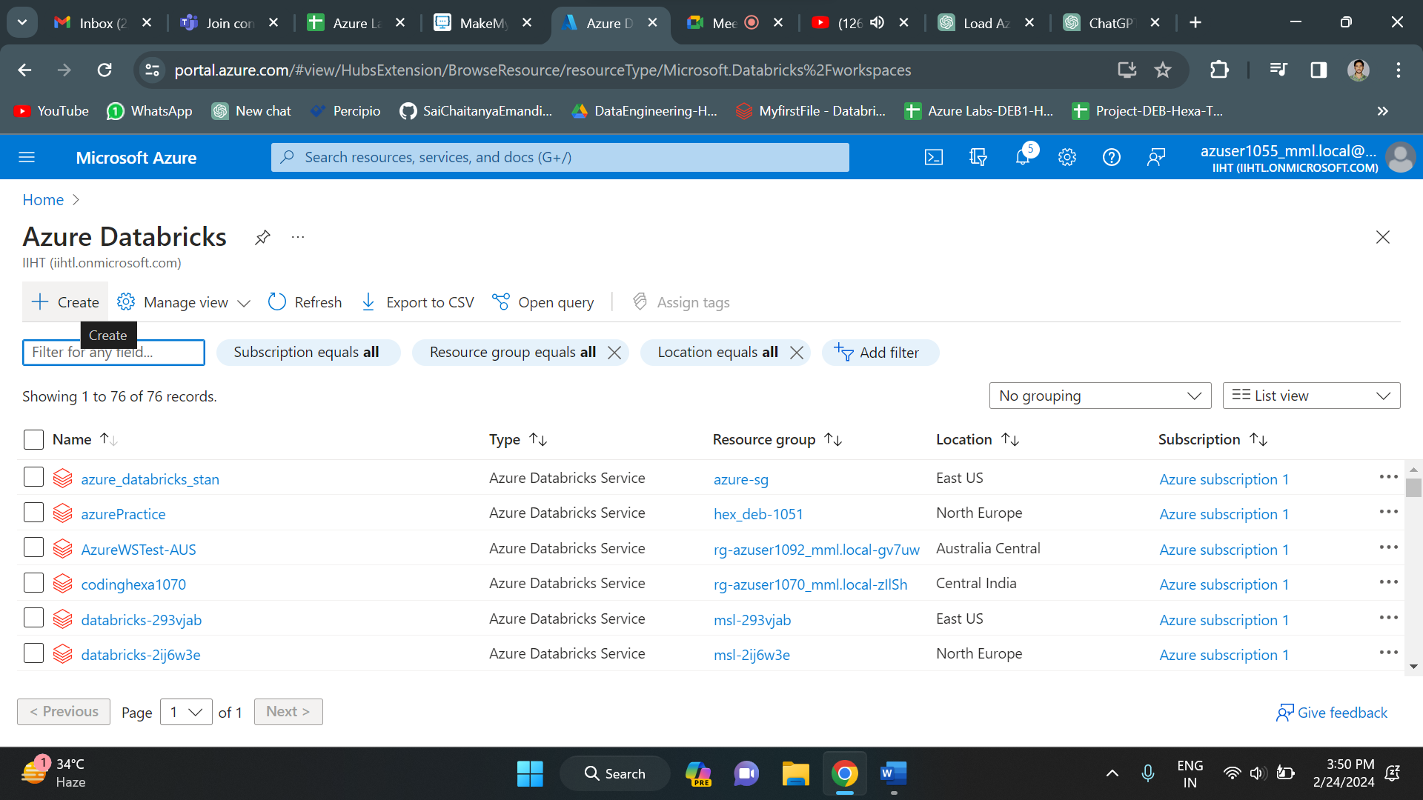

Fill all the details like resource group, databricks name etc. After successful validation click on create to create a new azure databricks account.

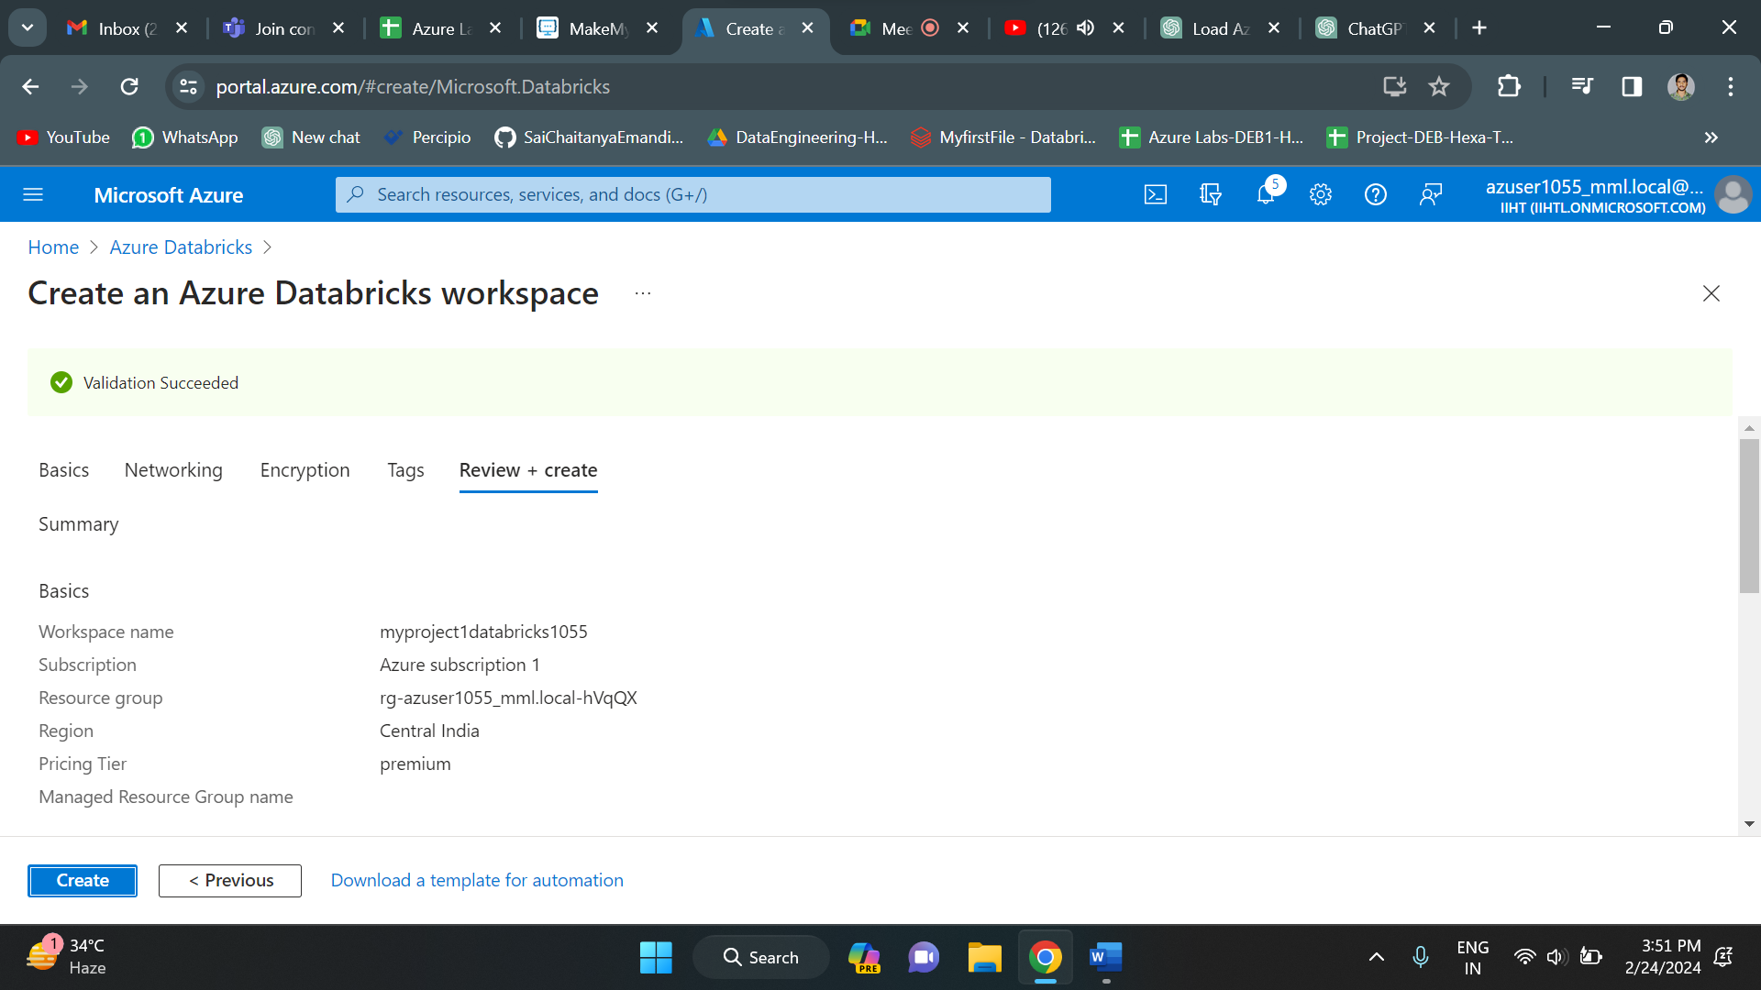

Once you click on create the deployment of azure databricks gets initiated and deployment will be in progress.Once the deployment is successful, click on go to resource.

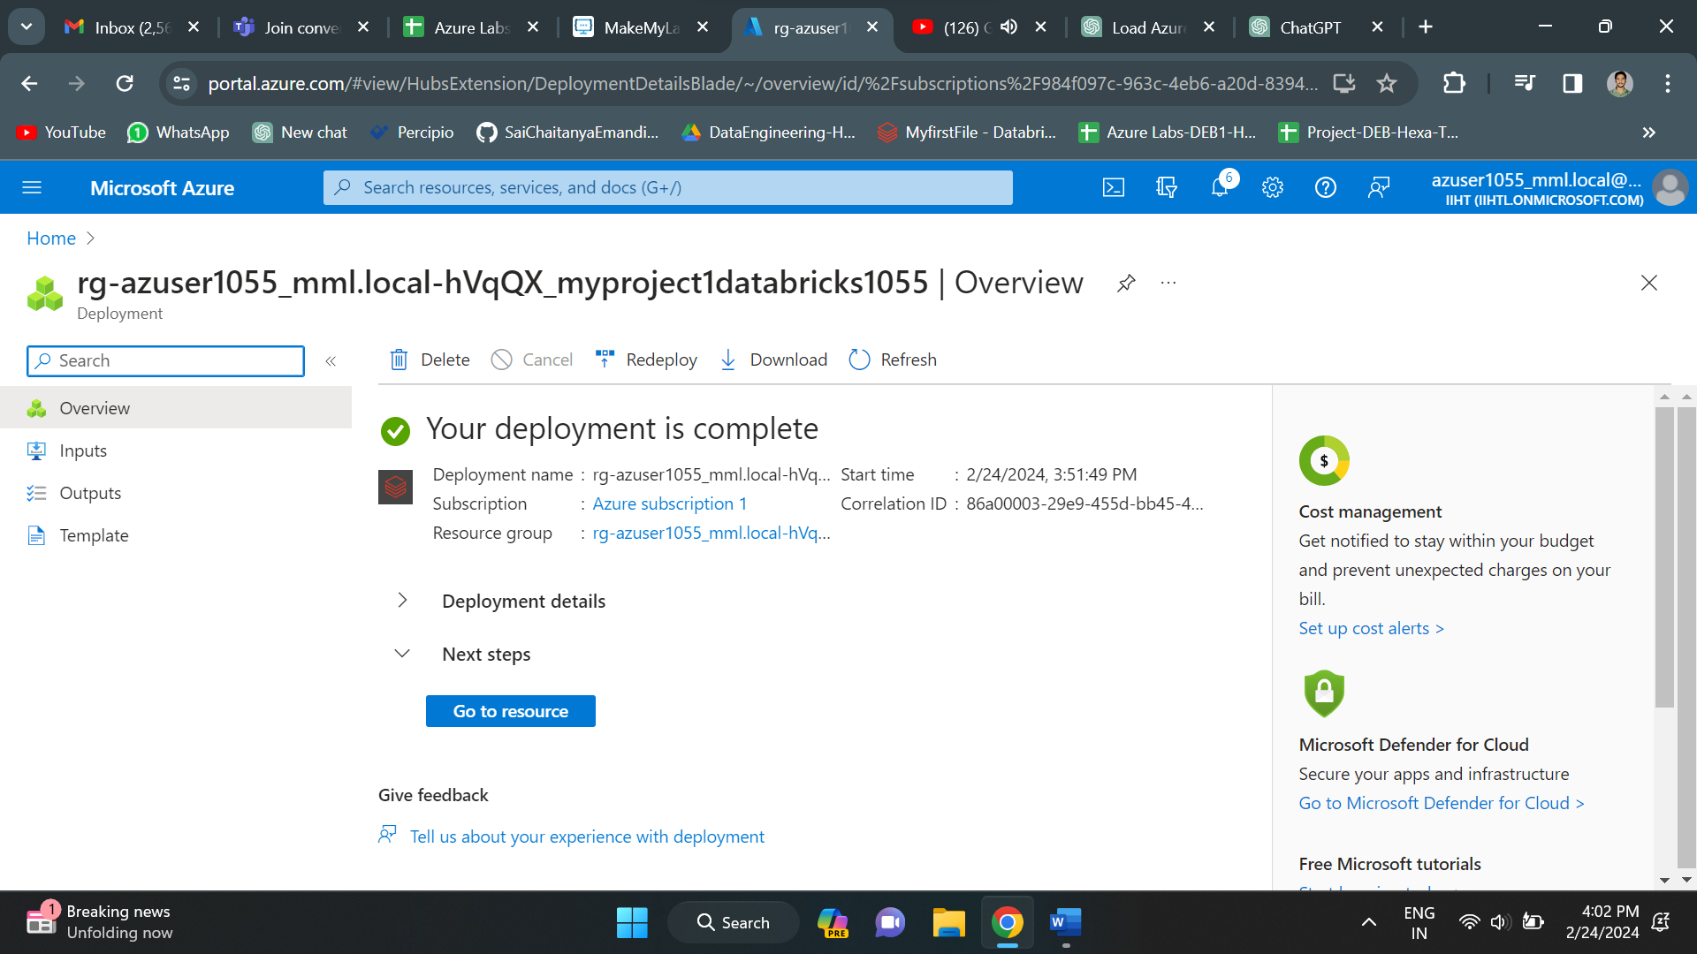

Below is the overview of azure databricks. It shows all the details of the account. Copy the URL and paste it in new tab.

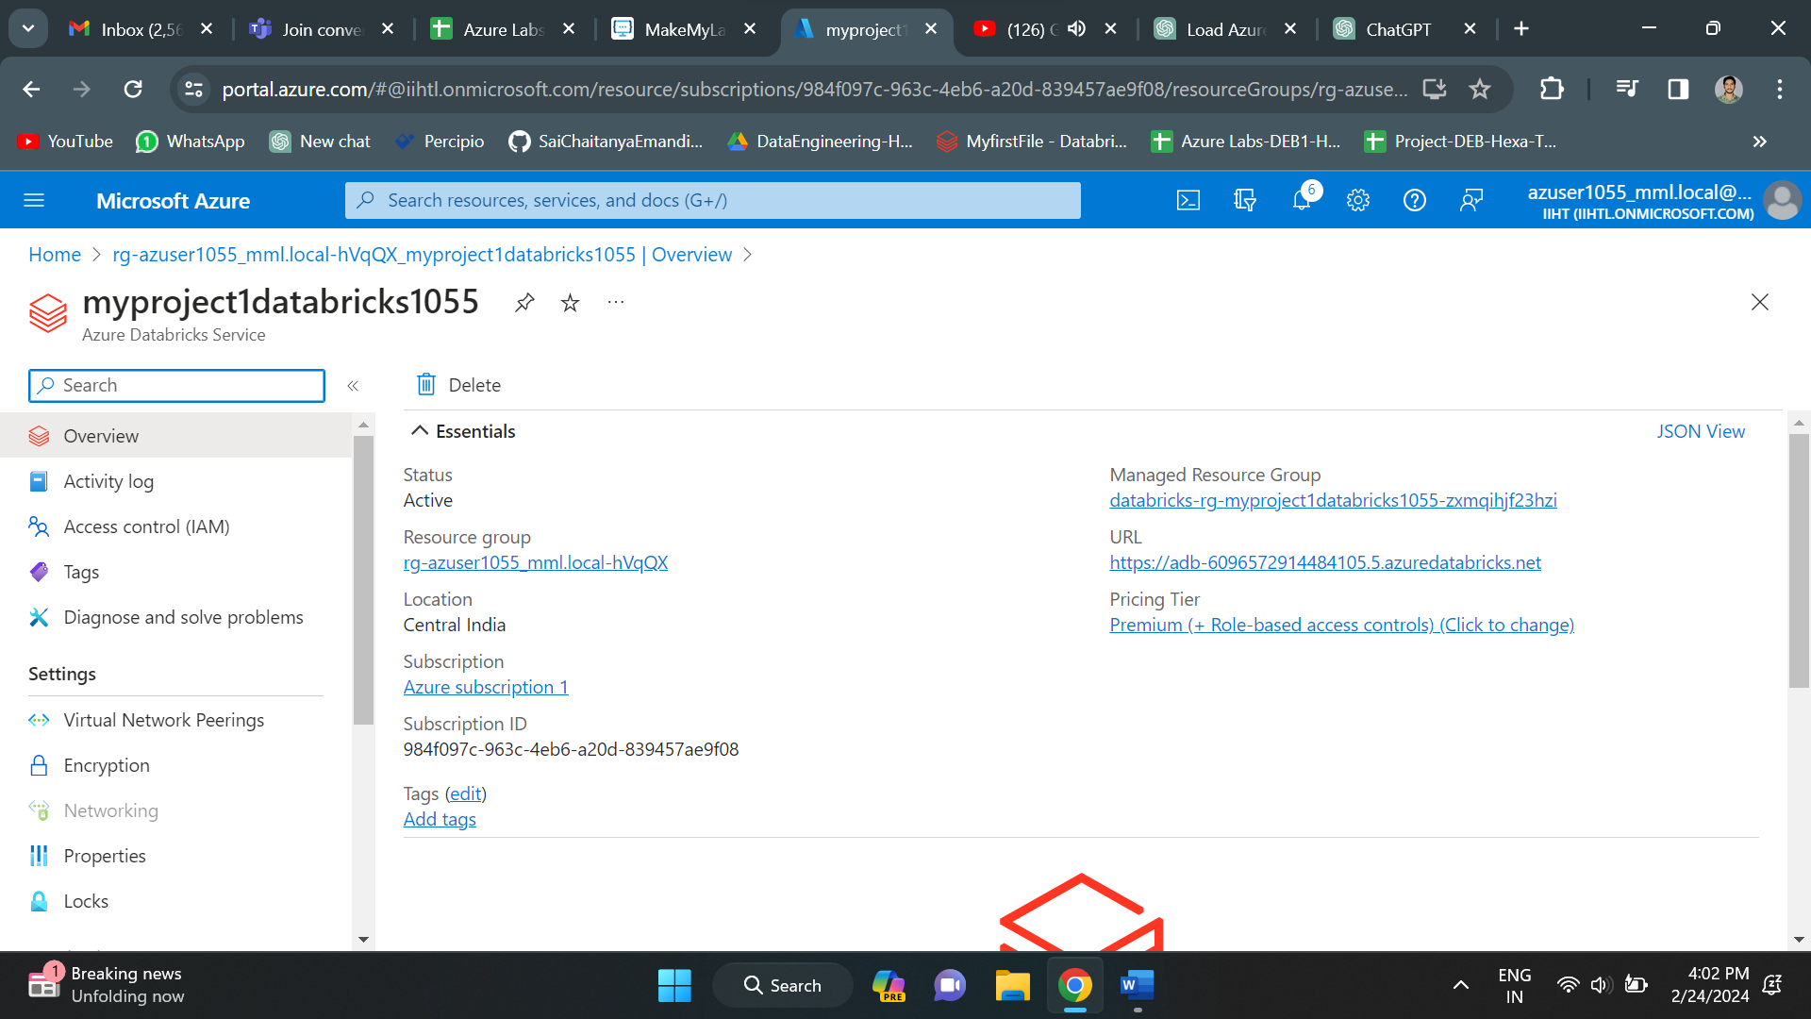

Below is the home page of azure databricks.

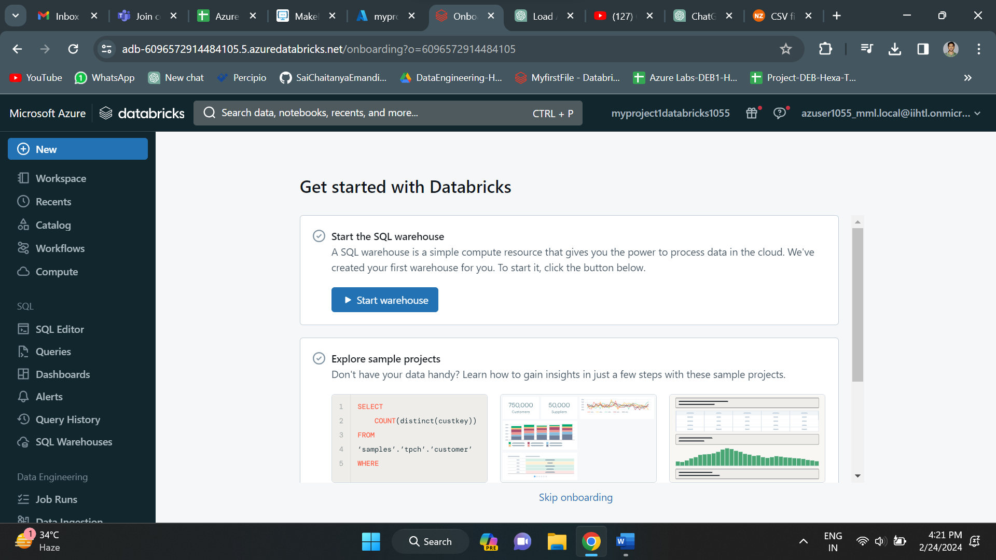

In order to perform any operations in azure databricks, we must create a cluster. Go to compute and click on create compute to create a new cluster.

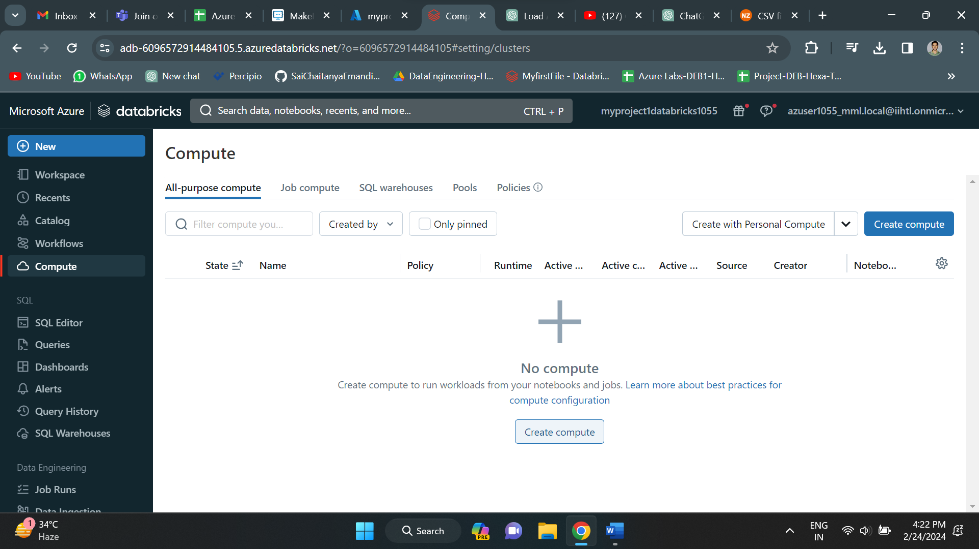

I have selected personal compute under policy parameter. Click on create to create a new cluster. As you can see below, the cluster got created successfully.

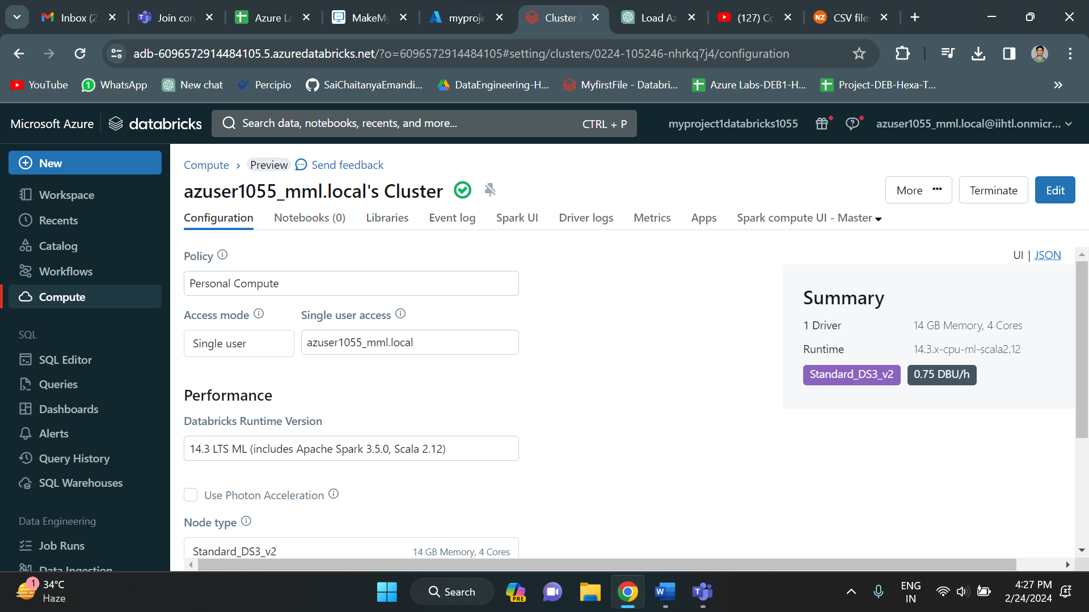

Now we can perform task in databricks. For this we need to create a new notebook.

Since SparkSession is an entry point to the spark, first we need to create a spark session. It represents a connection to a Spark cluster and can be used to create DataFrame, execute queries and perform other operations. So, I have created a spark session.

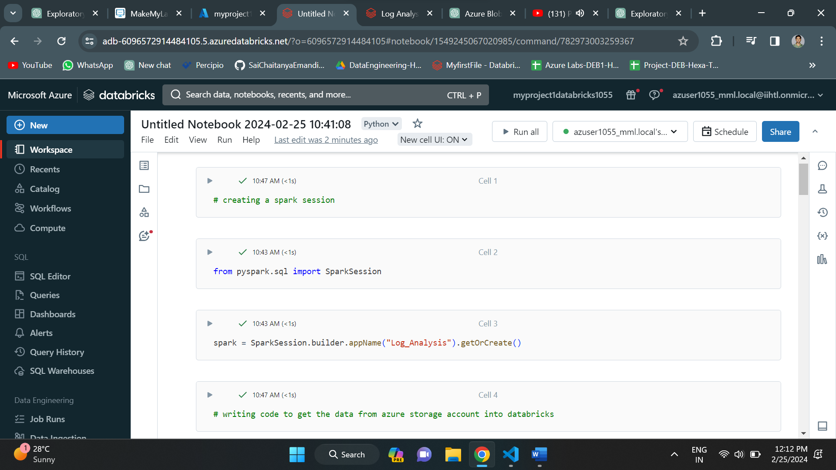

Now the spark session is created. We need to import the log data from azure storage account and use it here. For that I have created the required variables like storage_account_name, storage_account_key and container.

Next I have tried to set configuration. This configuration is necessary for Spark applications to read from or write to Azure Blob Storage. It essentially provides the necessary credentials for Spark to authenticate with Azure Blob Storage and access data stored within it.

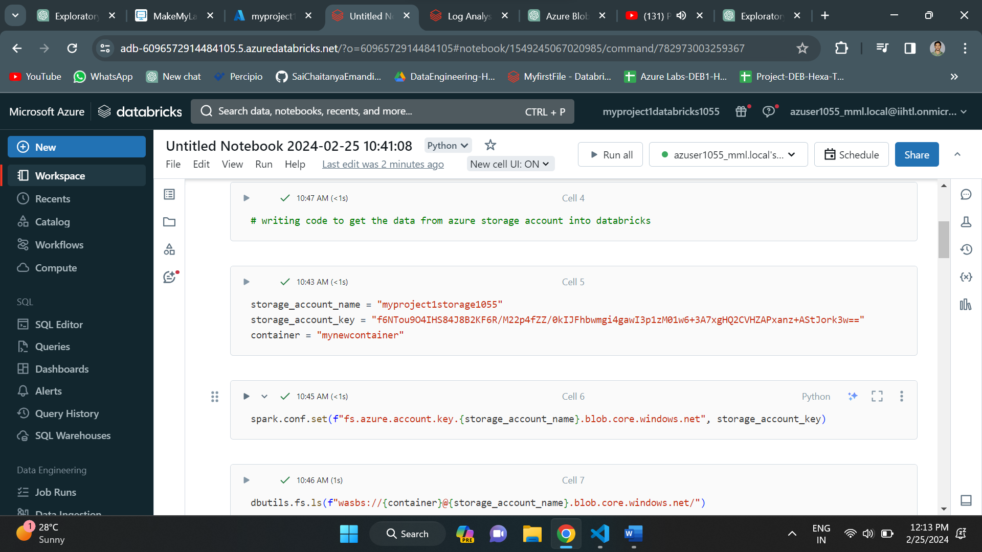

The values of storage_account_name and storage_account_key is taken from the access keys in the storage account. In azure storage account under security and networking, we have access keys option. In that we have storage account name and keys. We have two keys and we can take any of the key. Here I have taken the first key.

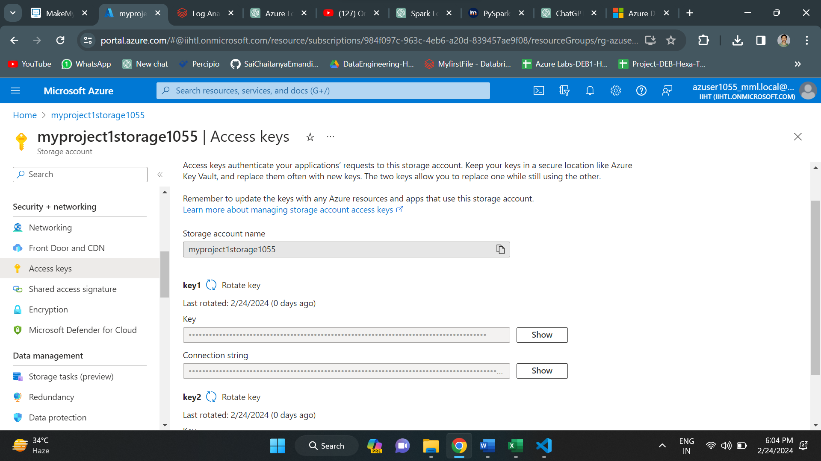

Next, I have used the dbutils databricks utility to retrieve the file located at the root of the specified azure blob storage container.

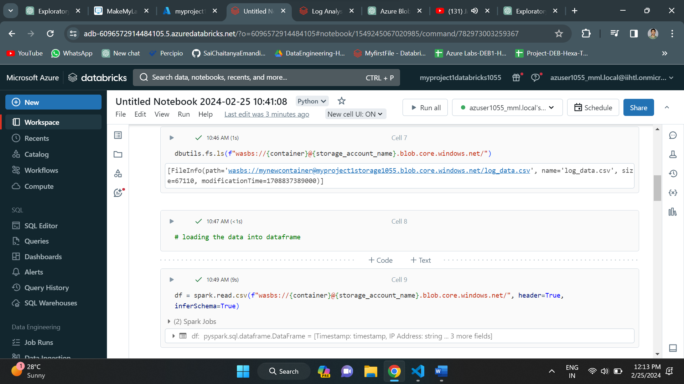

Since I have retrieved the log data file from azure blob storage, I have loaded it into a dataframe. After loading the data, I have written show to display the data in the dataframe.

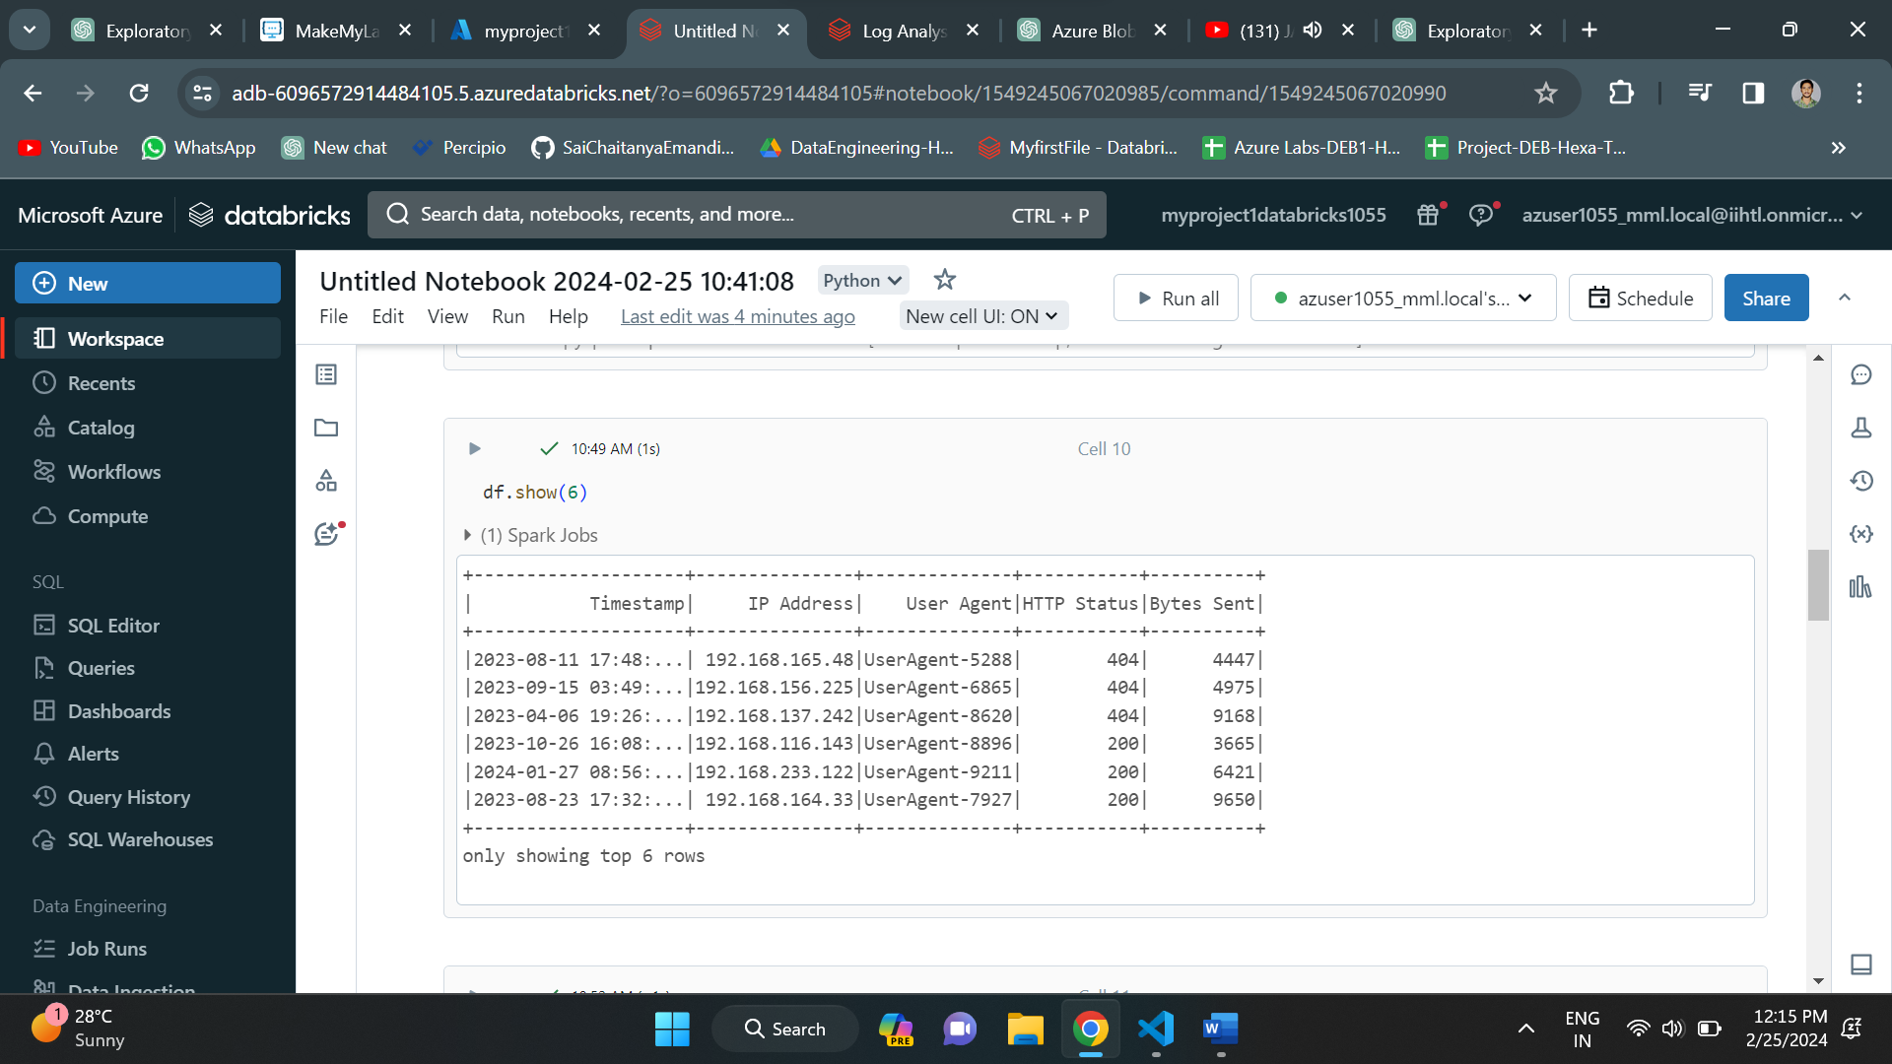

Instead of explicitly specifying the full path every time, we can use mounting in databricks. The statement below mounts the specified Azure Blob Storage container to the specified mount point in the Databricks environment, enabling access to the container's contents through DBFS.

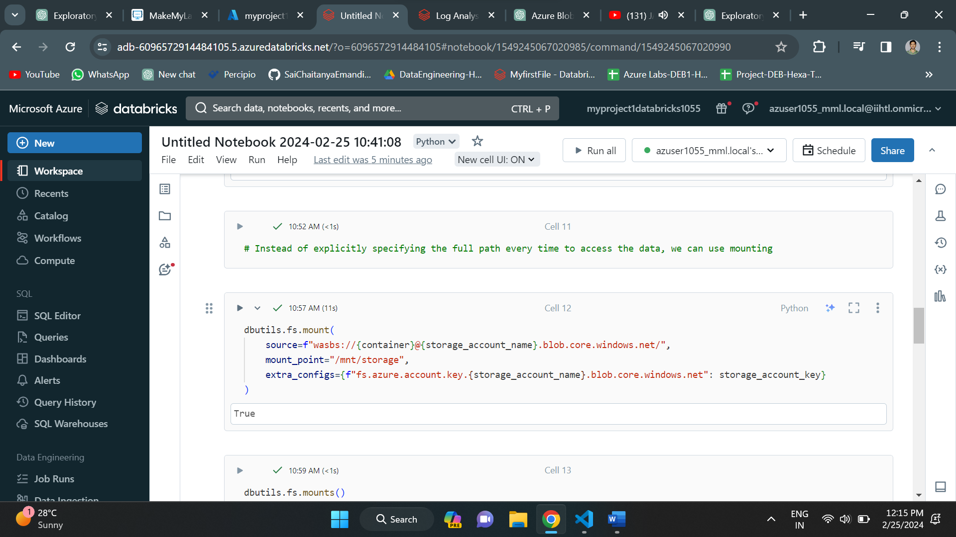

The dbutils.fs.mounts() statement in Databricks is used to list the currently mounted file systems in the databricks environment.

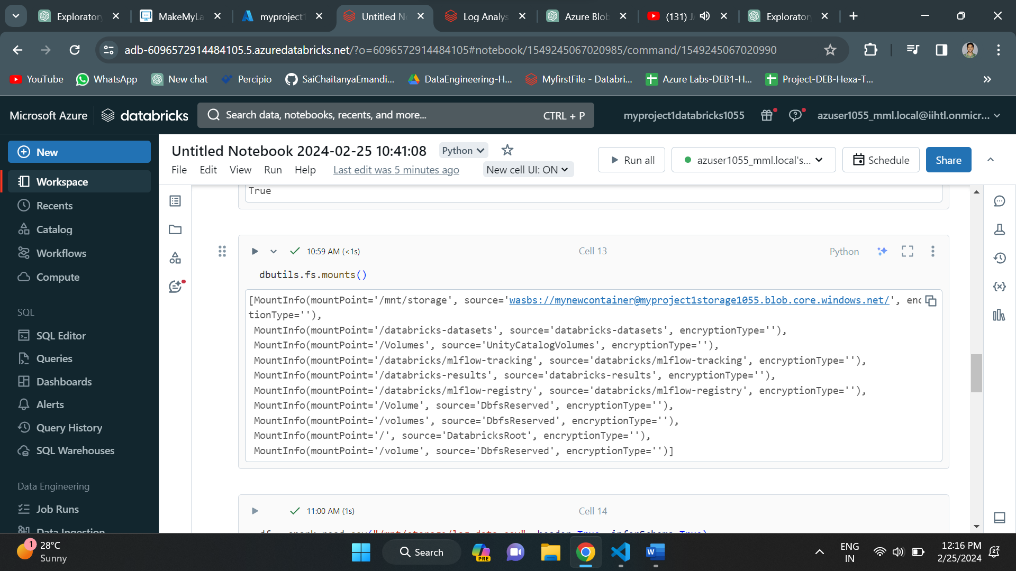

Since we have mounted the blob storage, we can directly access the log data file through DBFS. So, I have again created dataframe and read the csv file from the mount storage.

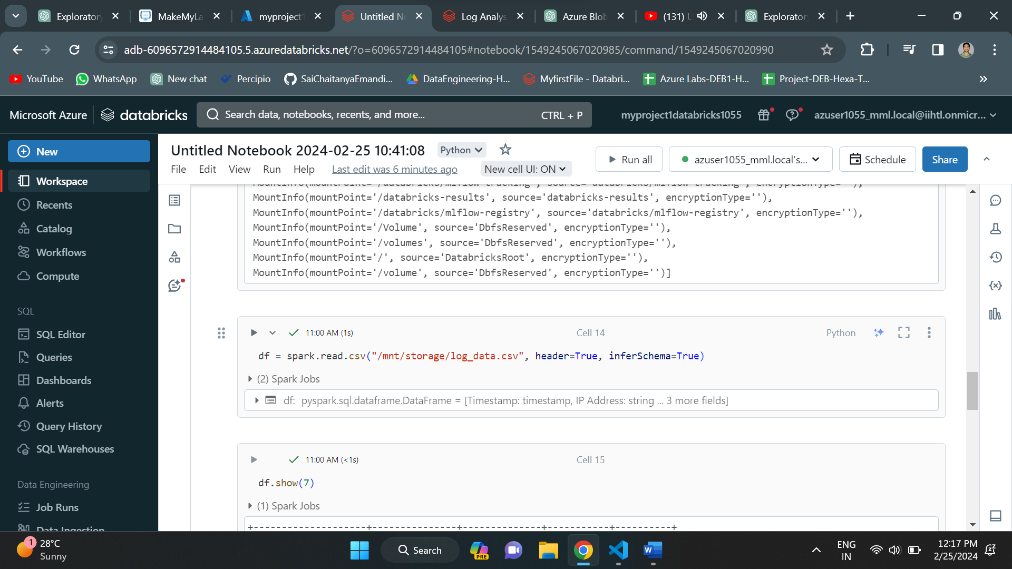

I have written show to show all the records of log data.

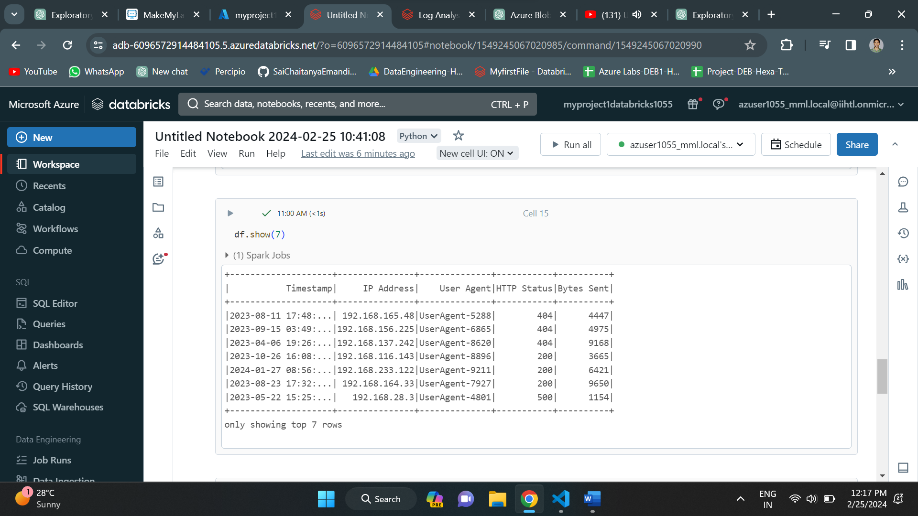

Below we have print schema which will give the overview of the schema of the log data csv file.

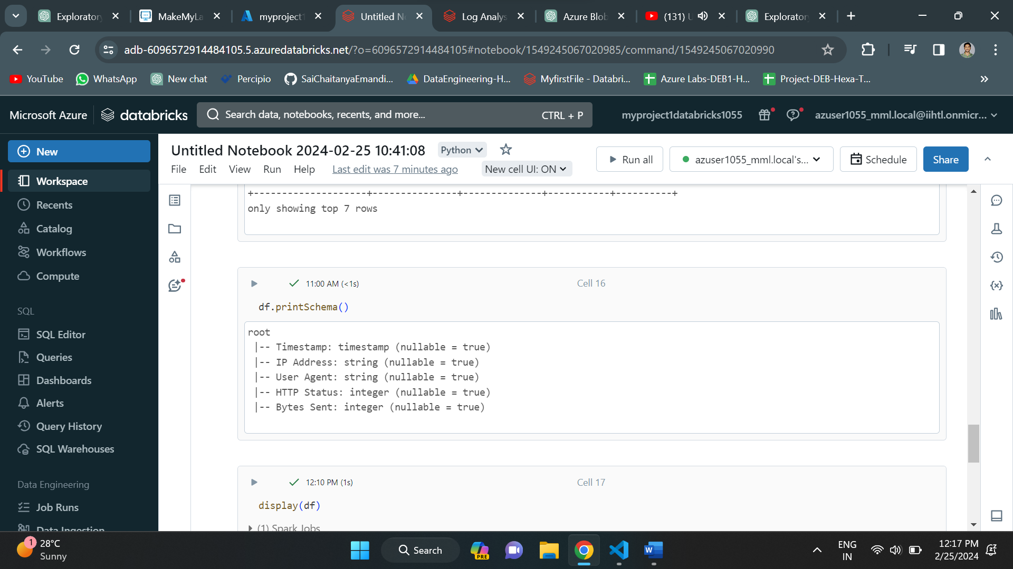

Now, let us visualize the data using visualization in azure data bricks. For that first we need to display the data using display method.

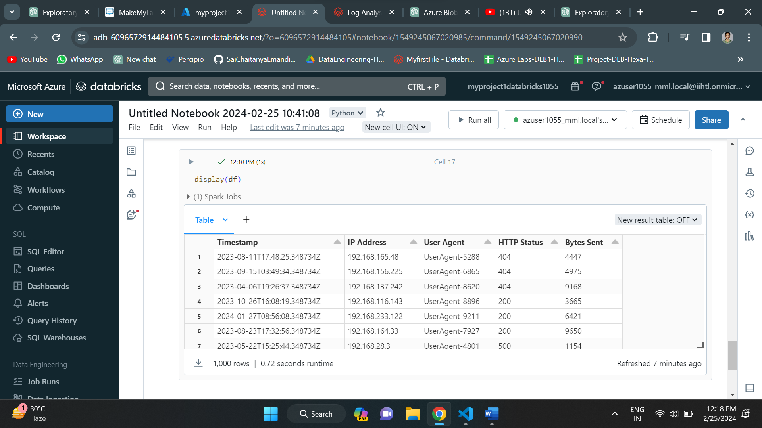

Using display we can display the table. For visualization click on “+” button and select visualization option.

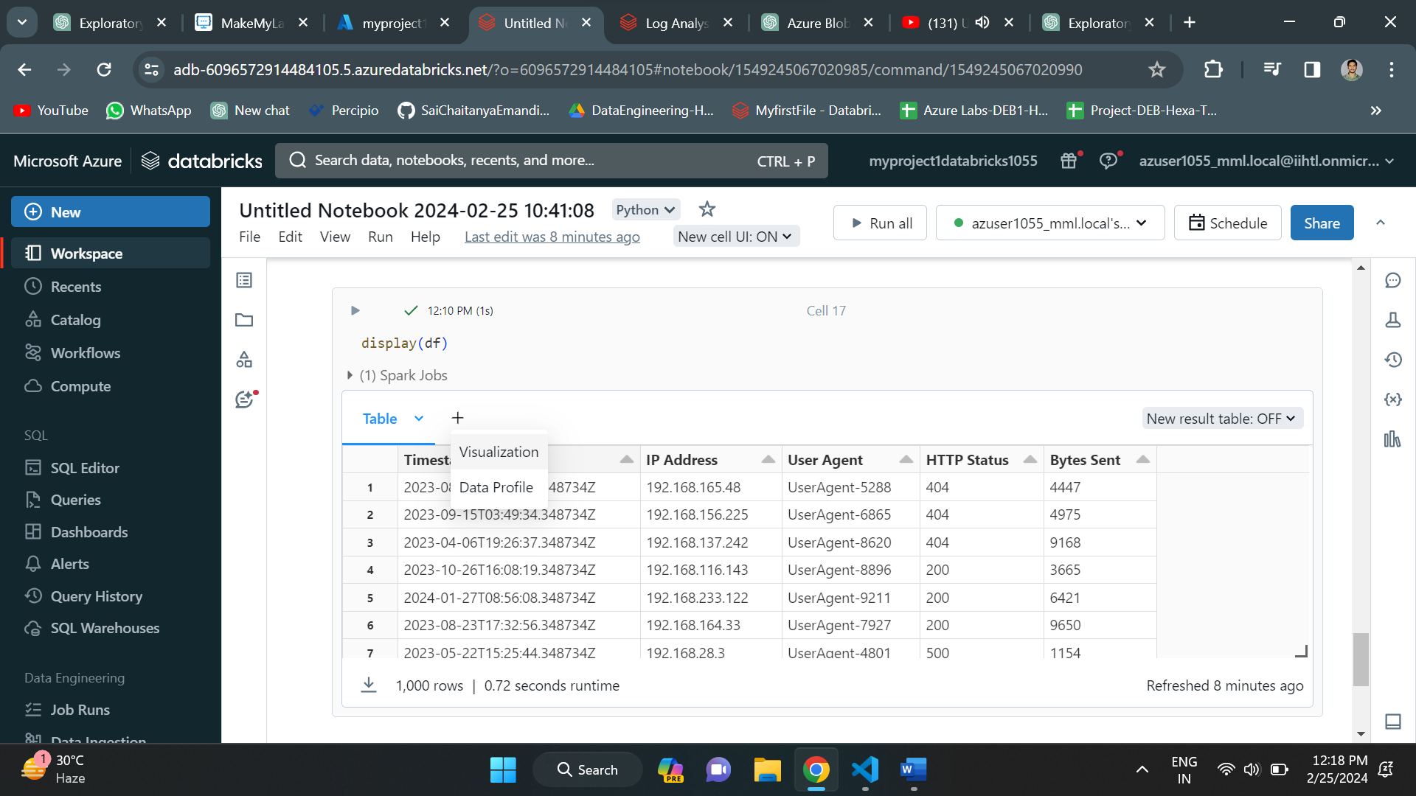

Select the x-axis and y-axis columns. And we can also group the data using a column.

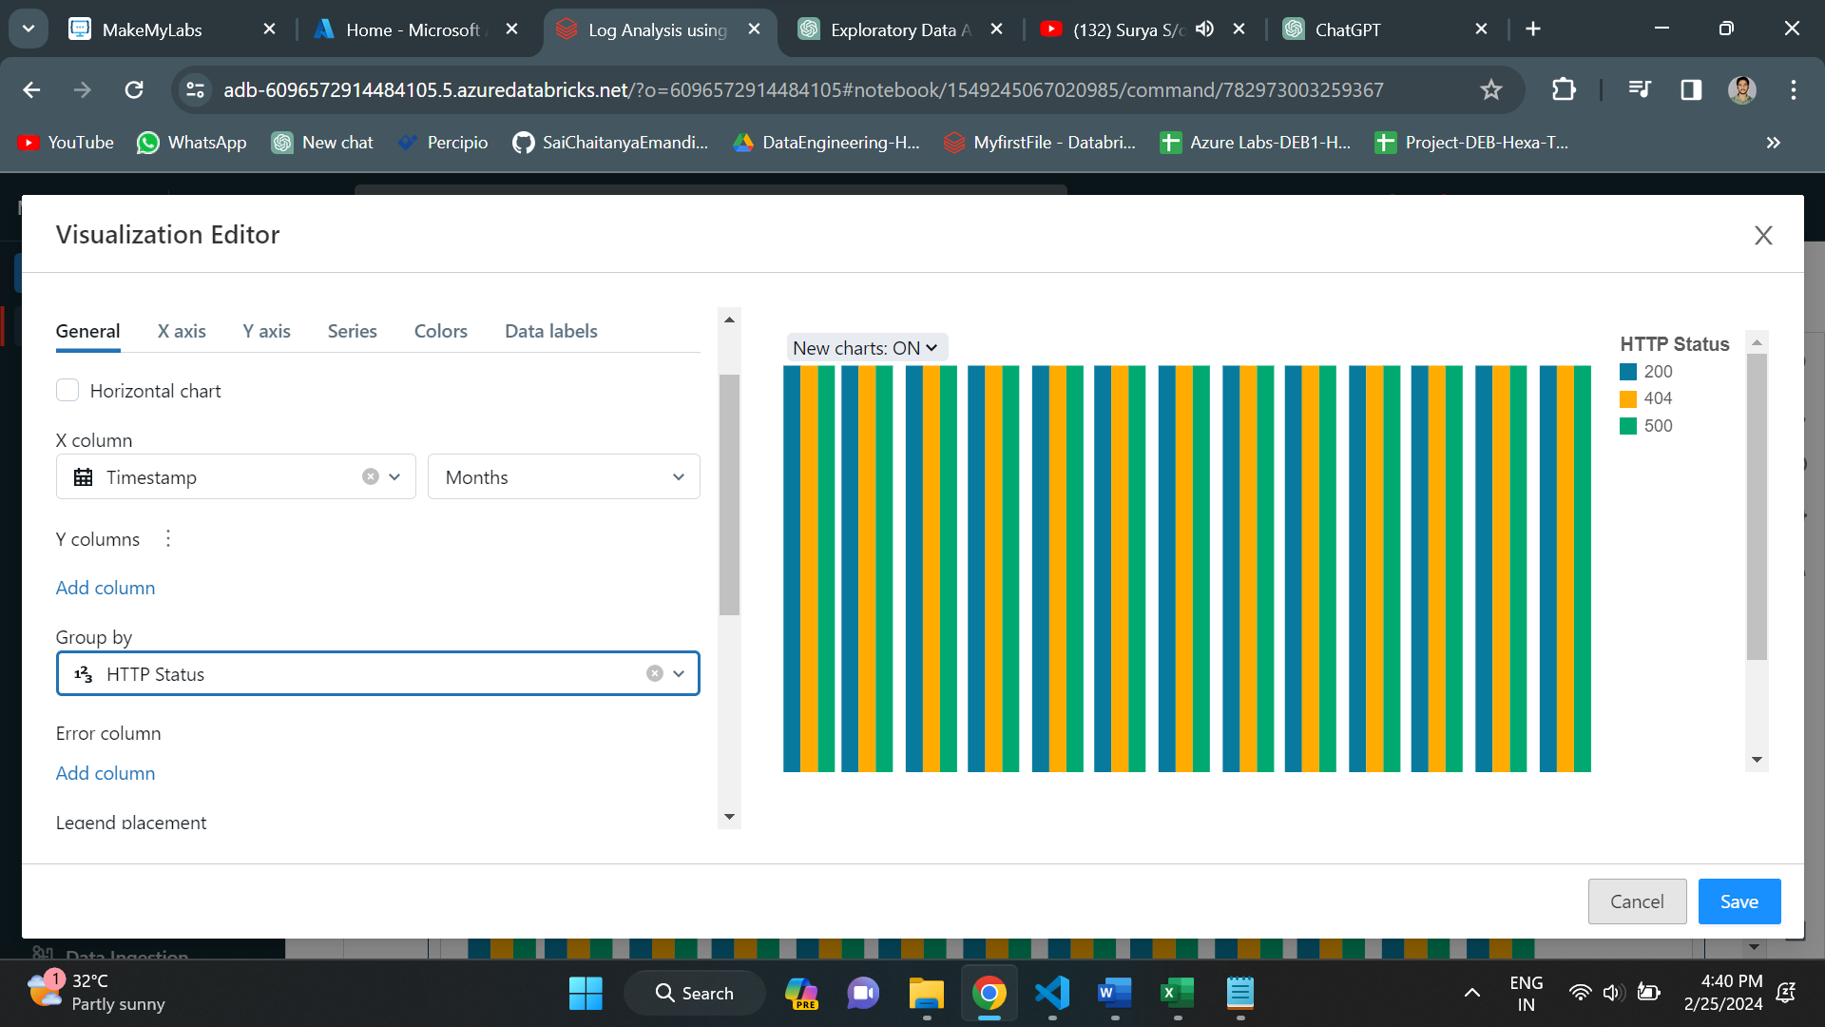

I have selected bar graph and given all the details. Below is the visualization of data in months group by ‘HTTP Status”.

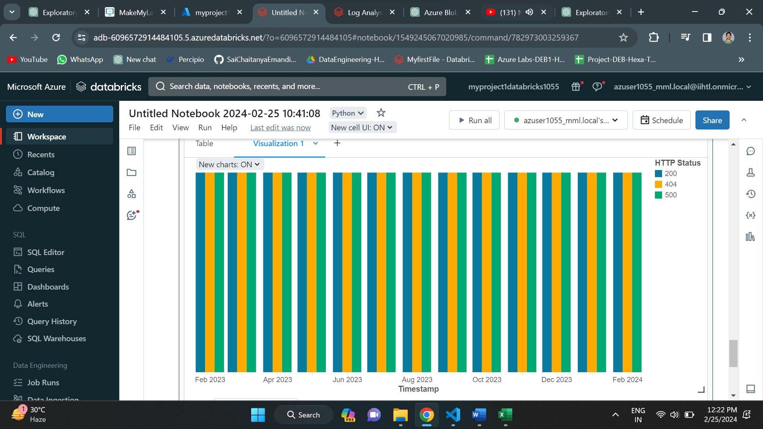

Now the visualization is done. Since the data may have missing values in it, I have applied some data cleaning method to delete the missing values. In pyspark, we have drop method to drop all the records containing the null values.

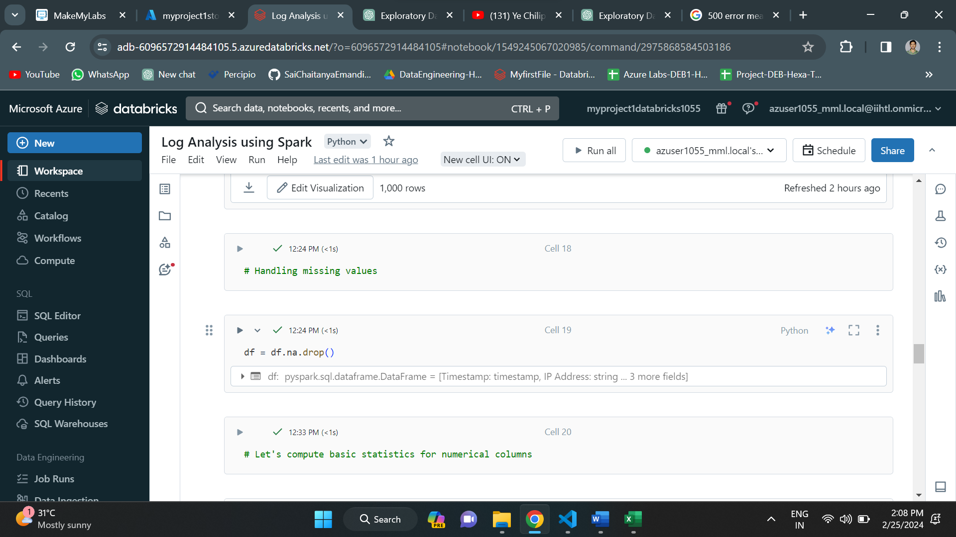

After handling all the missing values, I have used describe method to compute the basic statistics like count, mean, standard deviation, min and max.

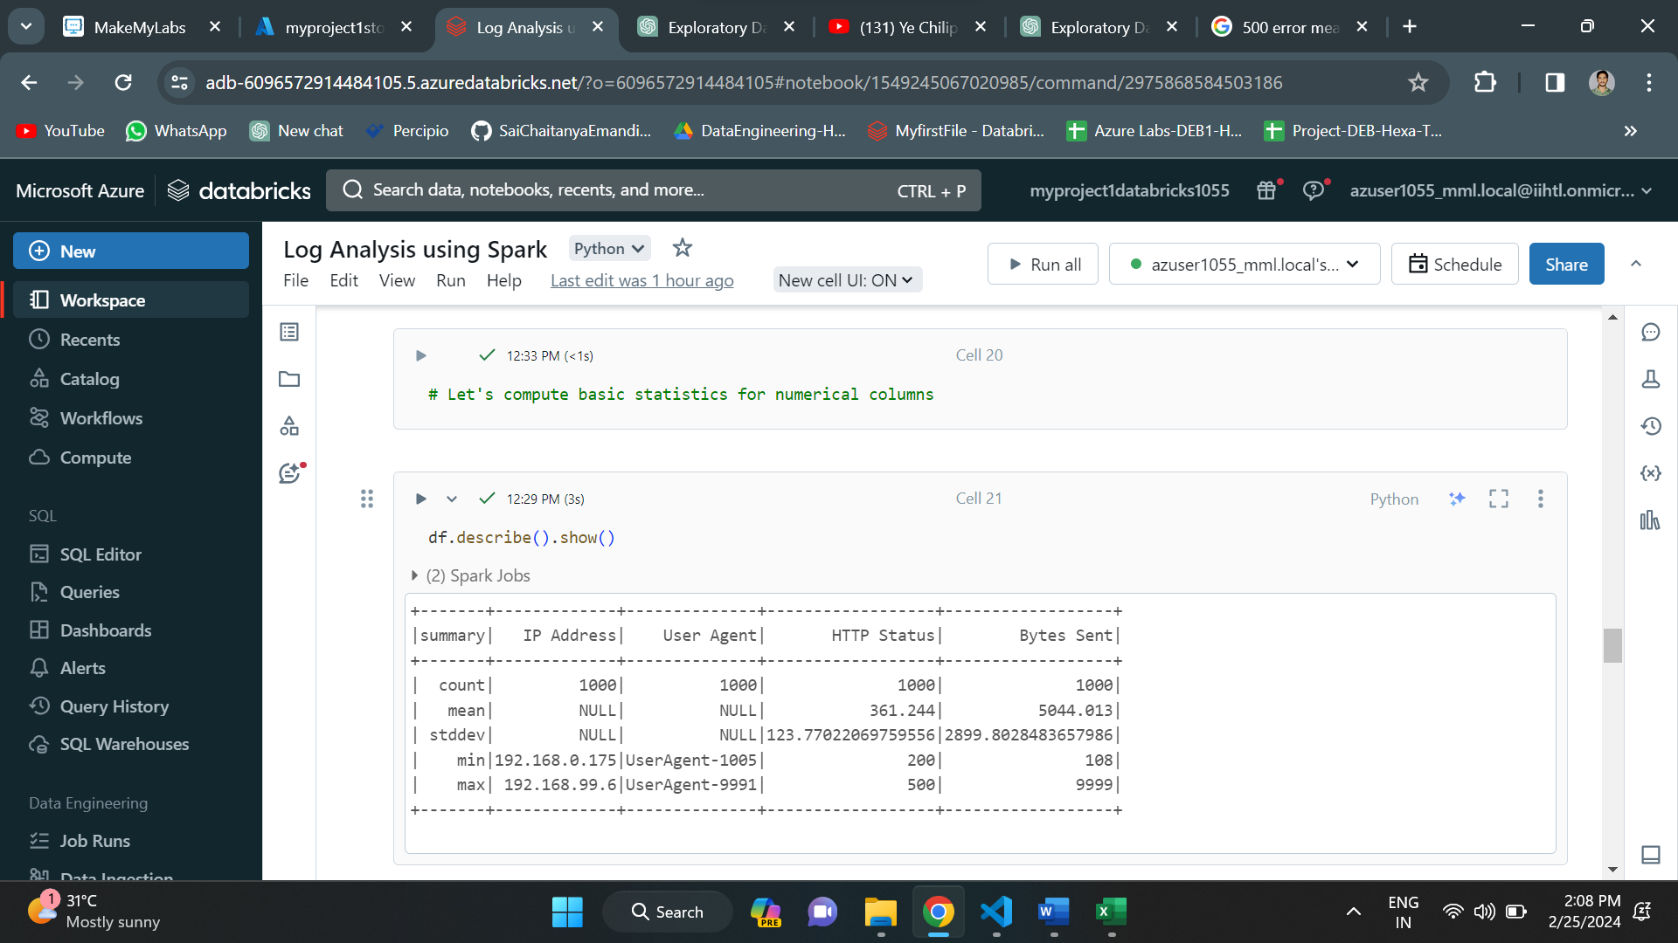

After the data cleaning and transformation process is done, I have written code to find the error rate of the data. Here I have assumed that “HTTP Status” codes 404 and 500 are errors. Based on this assumption, I have derived the error rate.

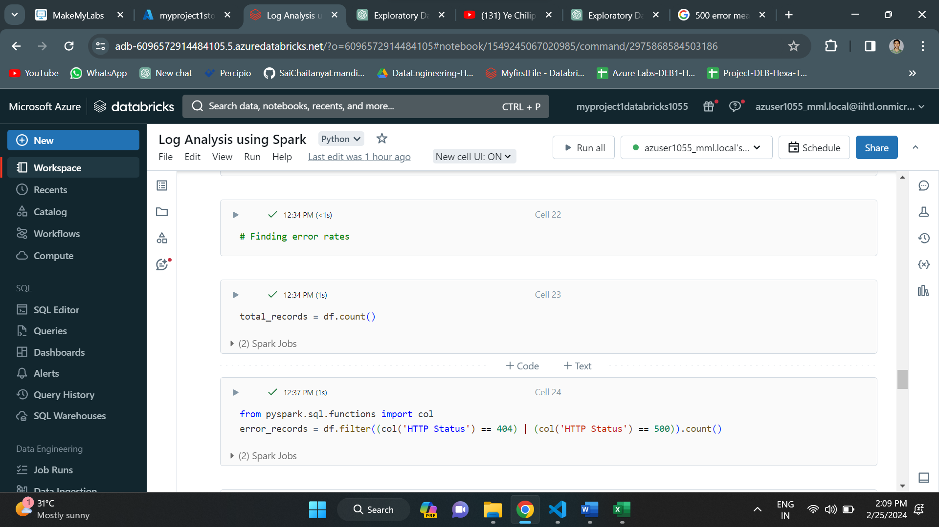

Below is the error rate of the data.

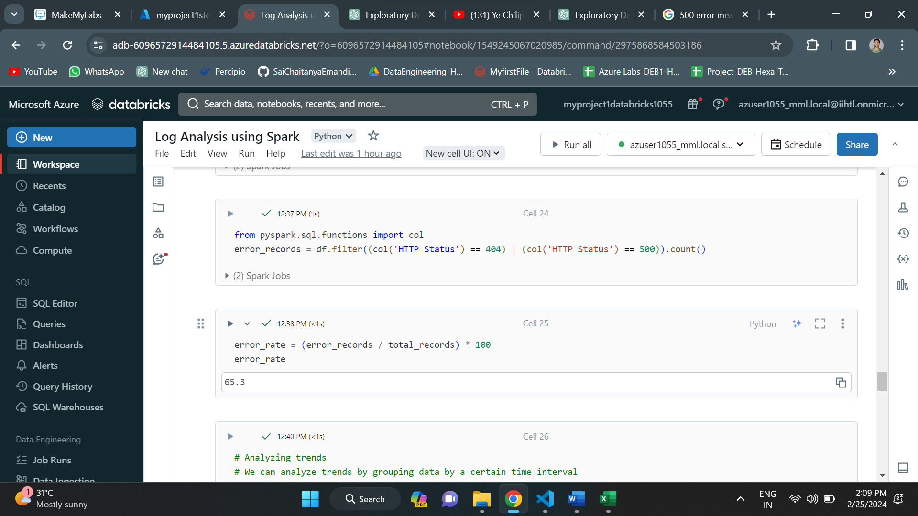

Now I have tried to analyze the trends in the data. We can do that by grouping the data on particular constraint.

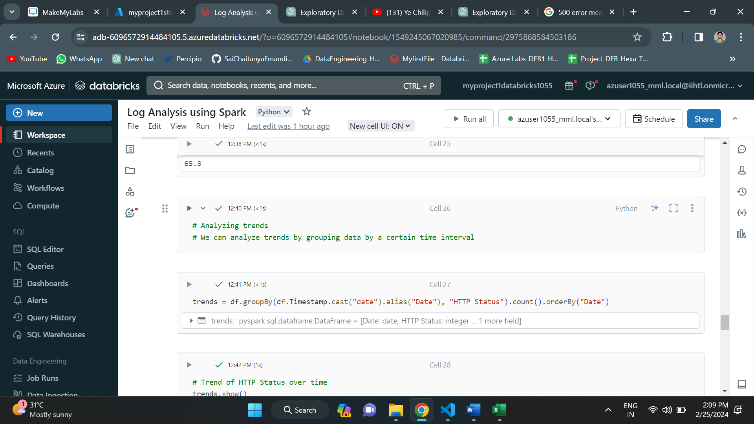

Here I have derived a trend based on “HTTP Status” column over time constraint.

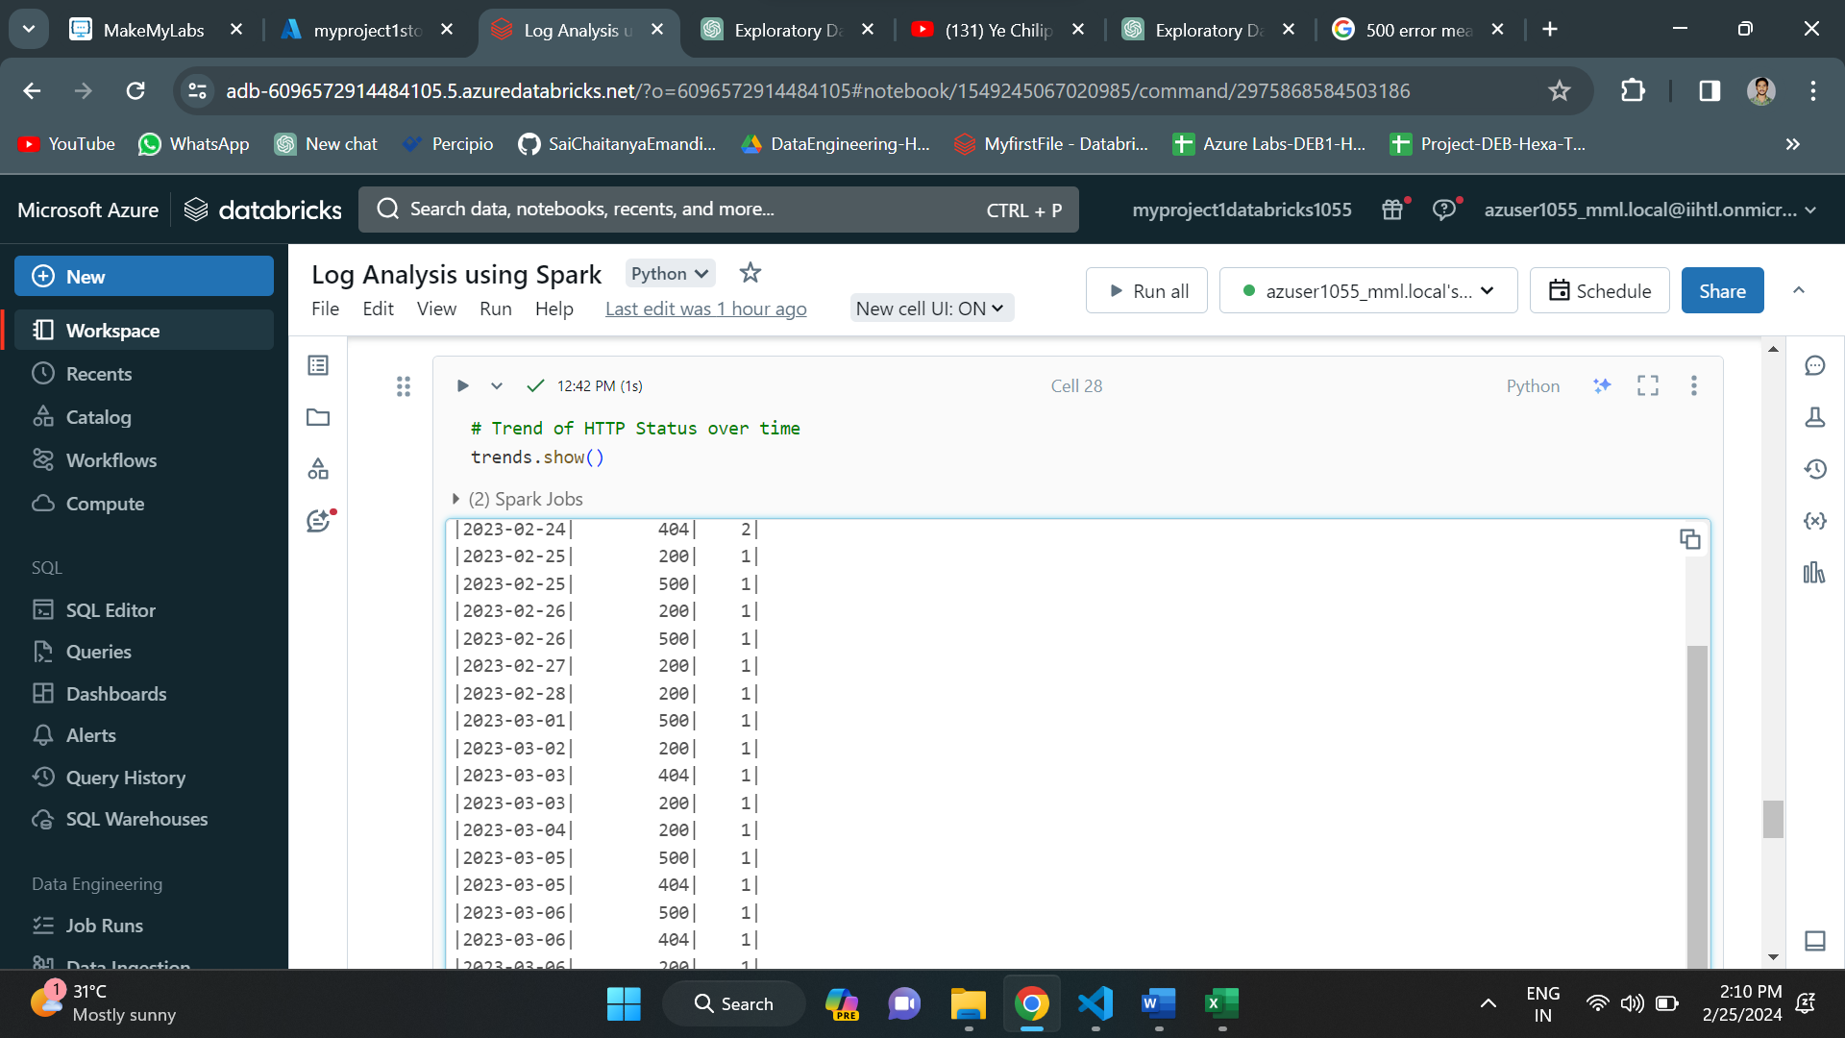

Below is another trend based on Ip address over time.

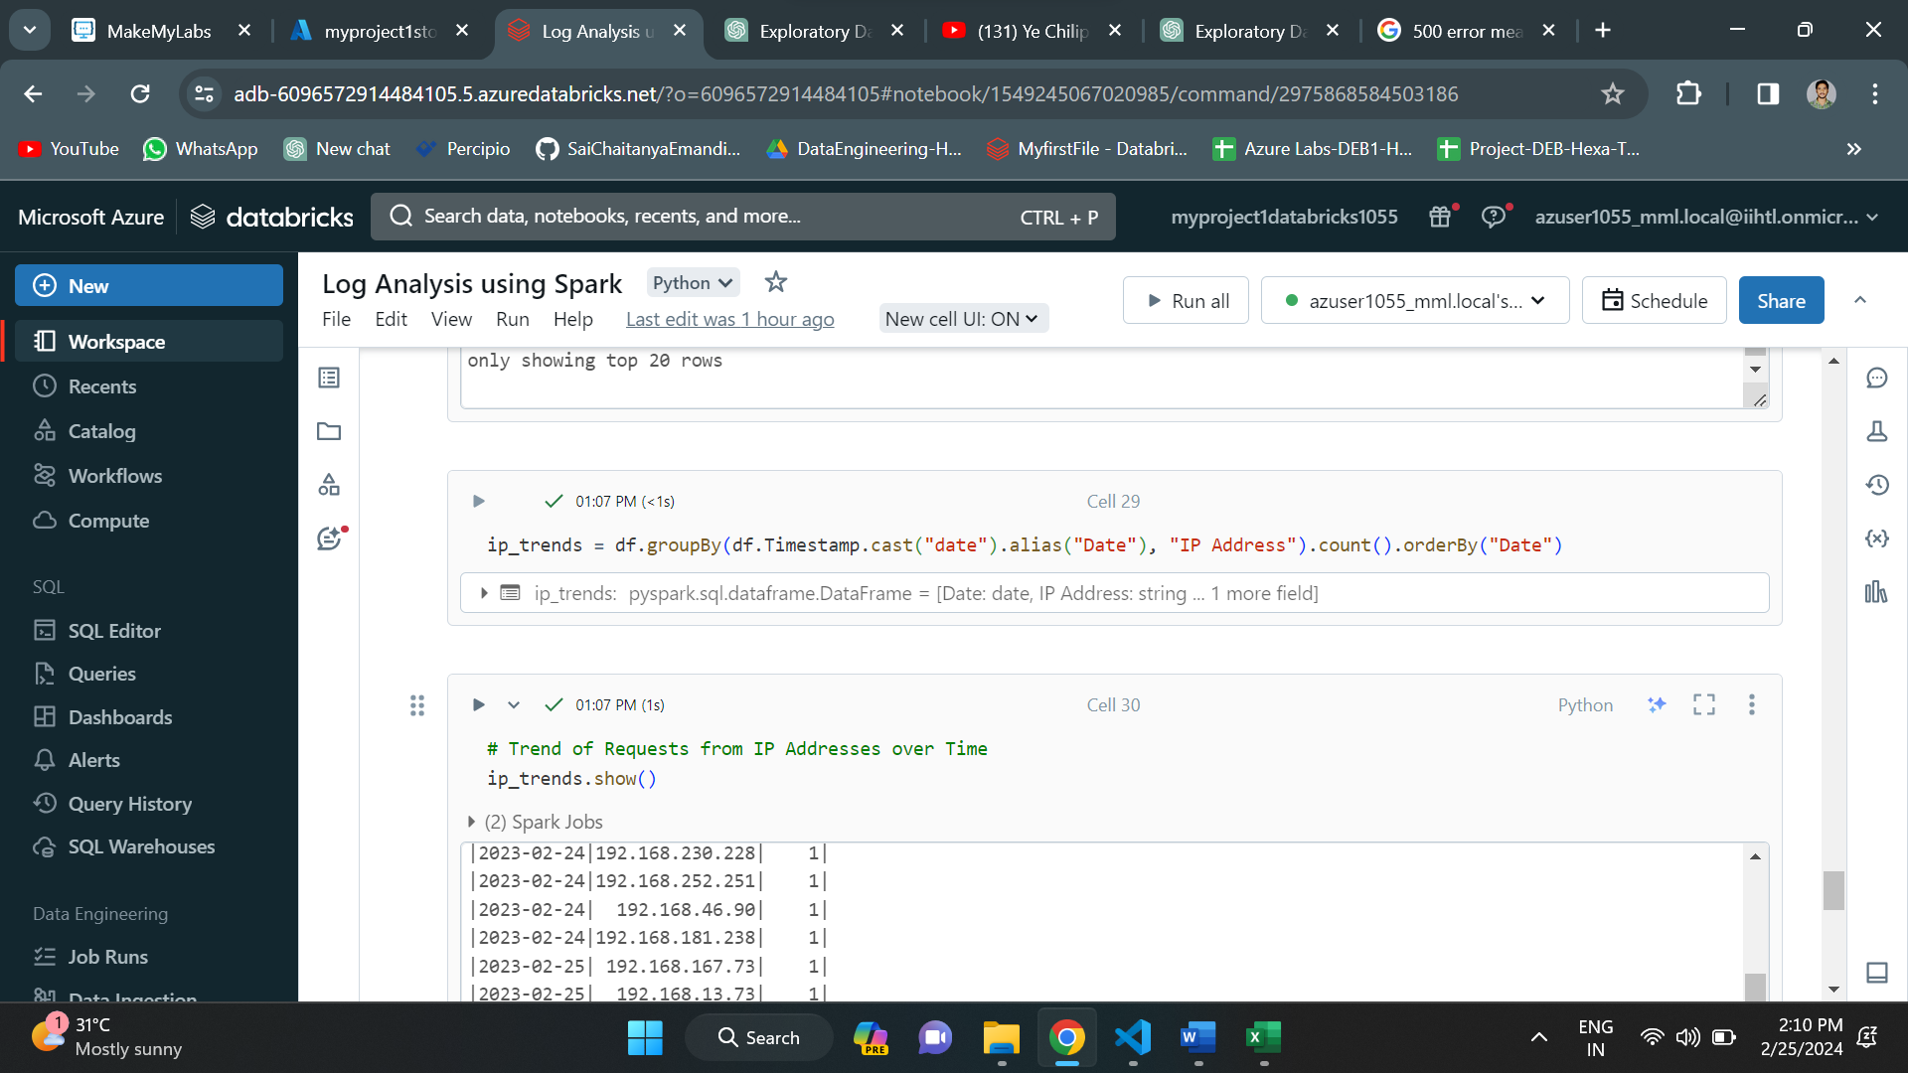

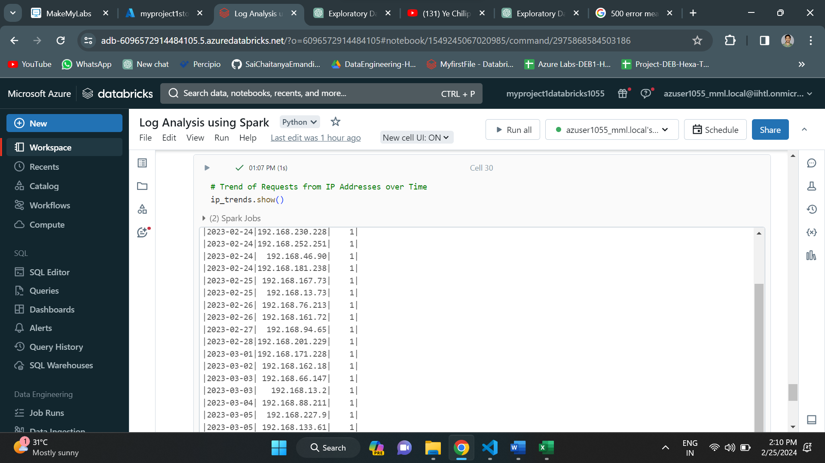

**CONCLUSION:**

The project successfully utilized Azure Data Factory for ingesting log data into Azure Storage and leveraged Azure Databricks with Apache Spark for log analysis. By accessing log data from Azure Storage and performing analysis tasks such as calculating error rates, identifying trends, and valuable insights were obtained. Through Spark's capabilities, the project facilitated efficient processing and exploration of large-scale log data sets. The integration of Azure services provided a scalable and reliable platform for log ingestion and analysis, empowering organizations to gain actionable insights, enhance system reliability, and improve decision-making processes based on log data patterns.